DFT Module Walkthrough

- Log into nanoHUB and search for Quantum Espresso. Launch the tool.

- The initial screen looks like this. Make sure “Si diamond” is selected under Premade atomic structure.
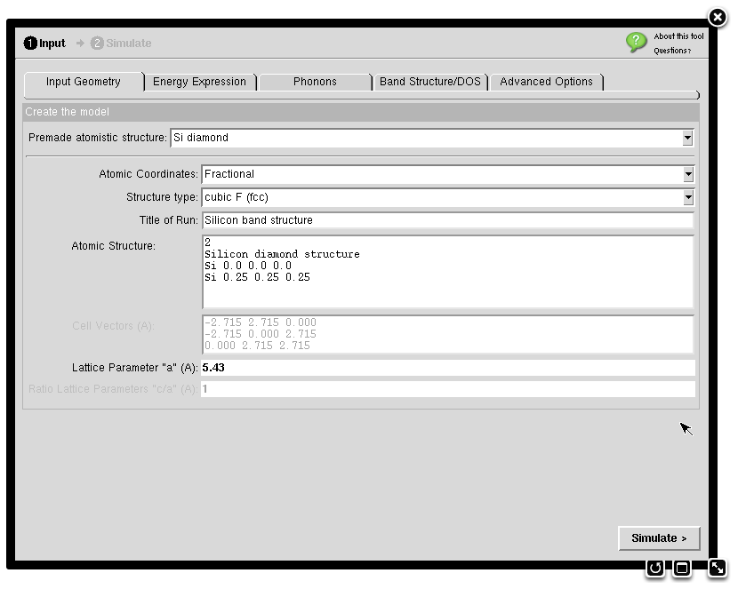

- For this assignment, you do not need to calculate the band structure or the density of states. Click on the “Band Structure/DOS tab and unclick the check marks for these calculations.
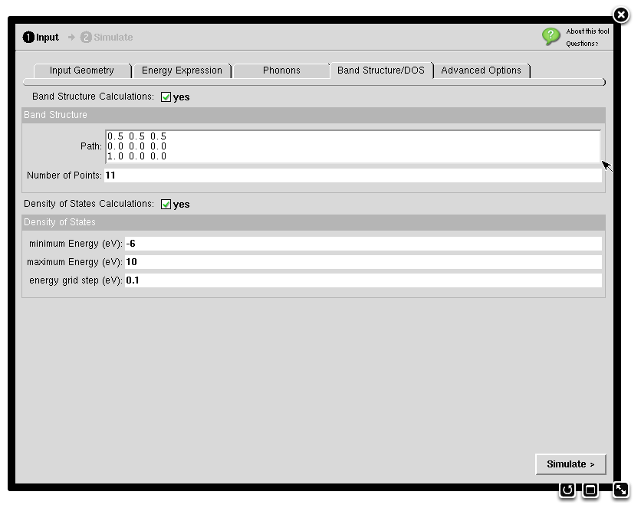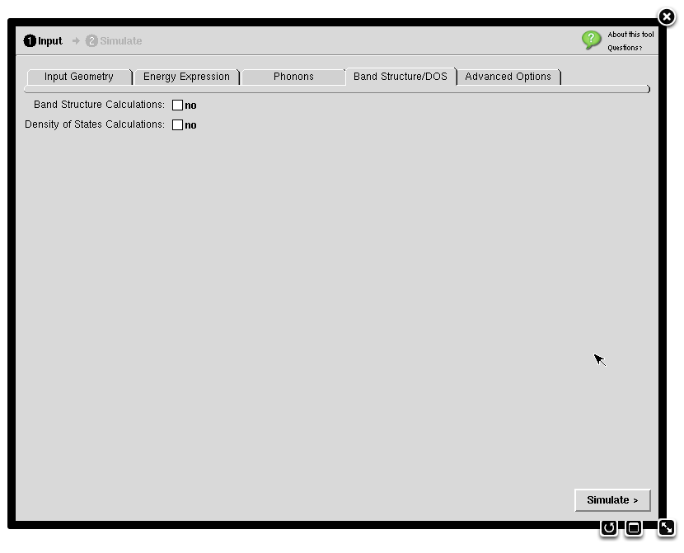
After
Before

- Click on the Energy Expression tab. The window should look like this.
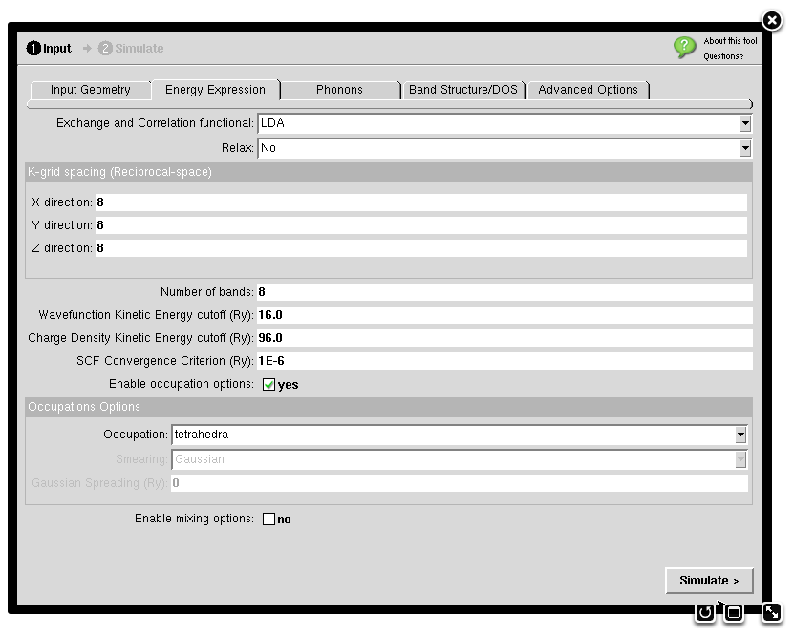

- Change the K-grid spacing to 6 (or another desired value) in each direction. Change the Wavefunction Kinetic Energy cutoff (Ry) to 24 (or another desired value). Leave other settings to default values. The screen should now look like this. (Note that Generalized Gradient Approximation (GGA) can be selected here if desired, but we will only use Local Density Approximation (LDA) in this module.)
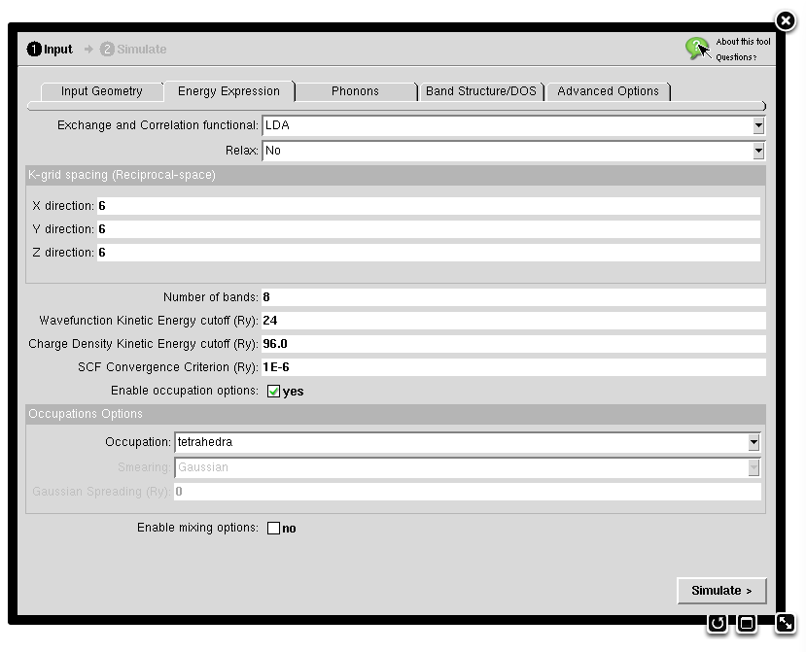

- Go back to the Input Geometry tab. Set the lattice parameter to the desired value (e.g., 5.35Å).
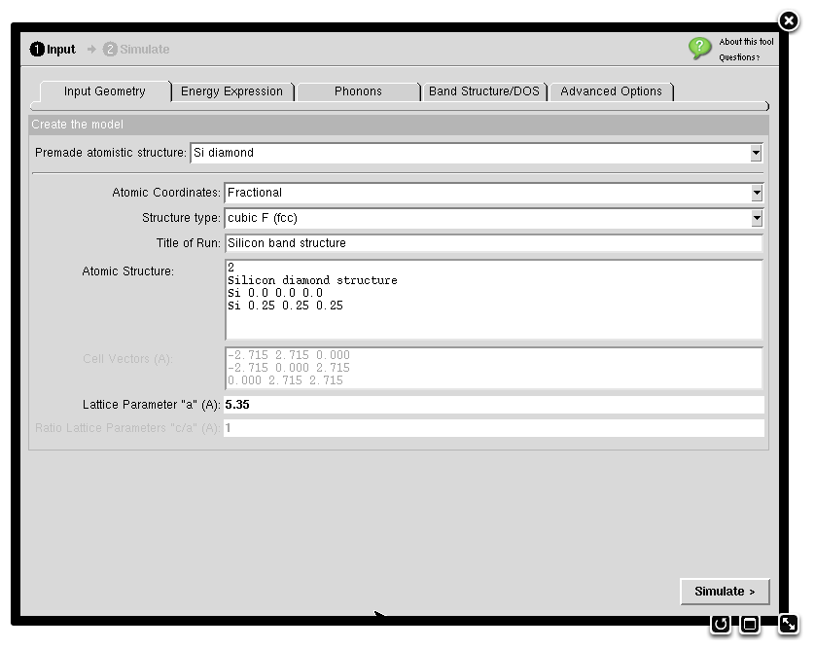

- Click on the Simulate button (see above) to perform the calculation.

- The simulation will run on the nanoHUB server, and the results will be printed on the output window. The output includes many pieces of information, including the intermediate results during the calculation’s iterative steps. The window will look like this.
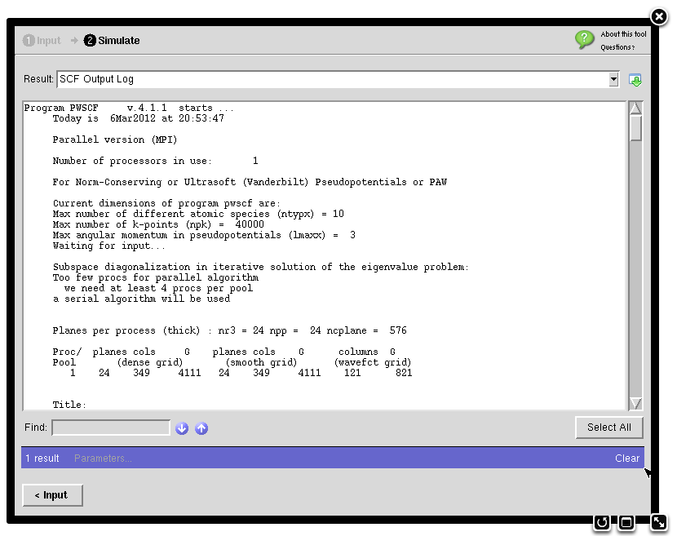

- In the drop-down menu, select Data.
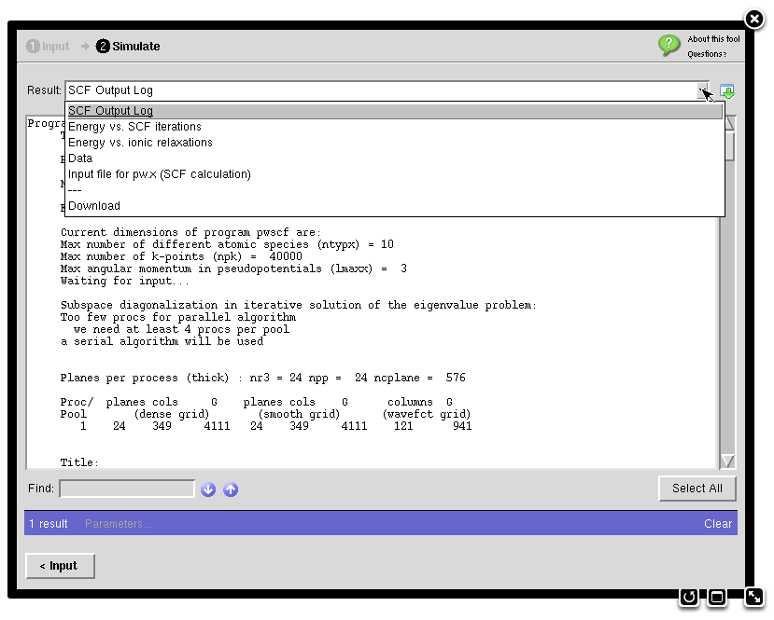

- Find the final total energy and pressure values. Record the values in the appropriate table entries.

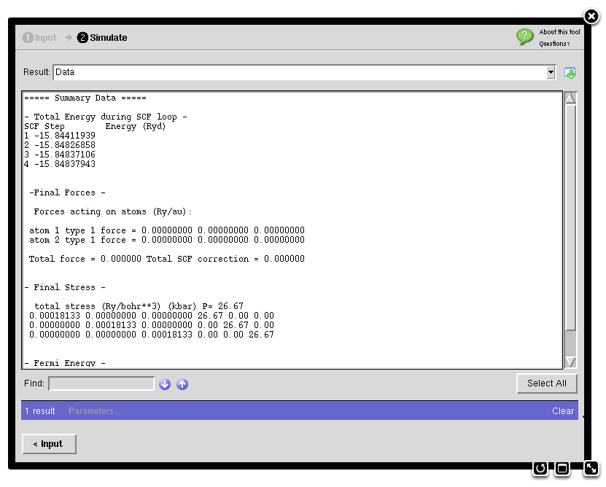

- Repeat with other parameters as necessary.

