ICMEd Summer School Kinetics Module
Summer 2018 Garcia/Asta/Thornton/Aagesen/Guyer

Summer School for Integrated Computational Education
Kinetics Module Problems

In the computational laboratory session, you learned how to use the Virtual Kinetics of Materials Laboratory (VKML) on nanoHUB to study diffusion kinetics. In this problem set, you will be using VKML to study both numerical aspects of the computational technique and concepts in kinetics.
Material science background
Diffusion occurs in a wide variety of materials during processing. For example, diffusion is used to dope semiconductors to fabricate devices. This process is called diffusion doping. The example below illustrates how a diode can be fabricated through this process.

Part 1: Numerics
- A 7 μm thick B-doped (p-type) Si wafer is annealed at 950˚C while in equilibrium with a gas containing P vapor (donor). The concentration of B in the wafer is 2x10¹⁷/cm³ = 2x10⁵/μm³. P diffusivity in this system at this condition is D≈10⁻¹⁴ cm²/s = 10⁻⁶ μm²/s. Assume that the concentration of P at the surface in this case is 10²¹/cm³ = 10⁹/μm³. To fabricate a device with a junction at approximately 1µm from the surface, one would like to match the P and B concentrations at a depth of 1µm. Using the following analytical formula determine how much time it will take for the concentration of P at a distance x=1 µm from the surface to be equal to the concentration of B.

Note that the erf function and its inverse can be evaluated using Excel or FiPy (you can also consider using the complementary error function, erfc, which is one minus the error function).

- Now let’s use FiPy to solve the equation and determine what time step is needed for the numerical solution to agree with the analytical solution. For this part of the problem set, use the 1D diffusion simulation script provided in the walk-through. Try time steps of 2, 20 and 200 and 2000 s. For a time of 10 hours and a distance of 1 μm, what value of time step gives agreement with the analytical solution to within one percent?

- The error function solution given above assumes an infinitely thick domain. Since your sample has finite thickness, this solution will not be accurate for your finite-sized sample beyond some time. To appreciate the effect, modify the code so that your sample is 1.02 micron thick. Compute the concentration at a depth of 1.02 microns after 10 hours (using the converged time step from part (b)) and compare with the analytical solution.

- What do you do if you want to reduce the time required for annealing? What “knob” would you control in your processing equipment?

Part 2: Two-Dimensional Solution

a. Now part of the Si surface is covered by a mask in the manner shown below.

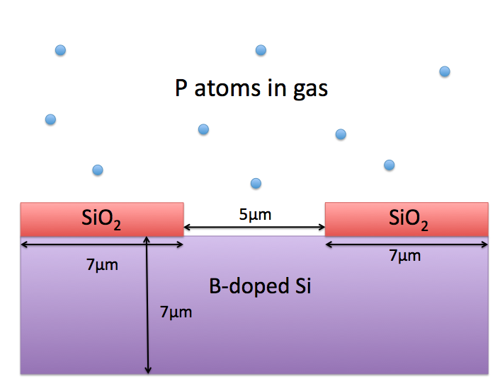
How would you set up the domain of the simulation? What boundary conditions would you impose and where?

b. Simulate diffusion doping for the above situation and plot the concentration profile near the surface using the script provided for 2D simulations. Qualitatively compare your result to the one obtained in part 1 (b). Please explain the similarities and differences and why.

