Mechanics Module Walk-Through

This walk-through was based on a similar one on the NIST web page at: http://www.ctcms.nist.gov/~rlua/redblue/index.html

NOTE: If OOF seems to have frozen up, it is often due to a small window asking you to make a selection. Look for them and click “Cancel” or “OK” to return to the main window.

1. Uploading the microstructure file

1.1 In your web browser, go to nanohub.org. Click on the Login button in the upper-right hand corner.

1.2 Log in using your nanohub username and account.

1.3 Click the Search button and type oof2 into the box that appears.

1.4 Choose OOF2 from the list of search results.

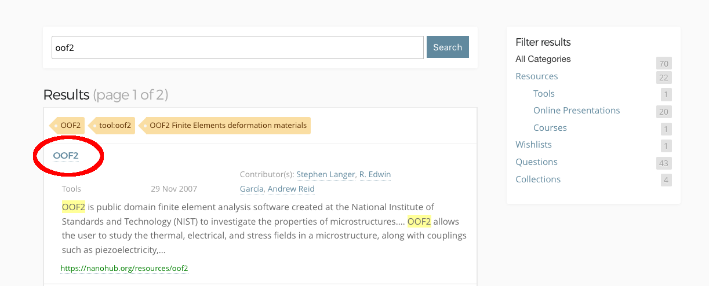

1.5 Click Launch Tool from the OOF2 page.

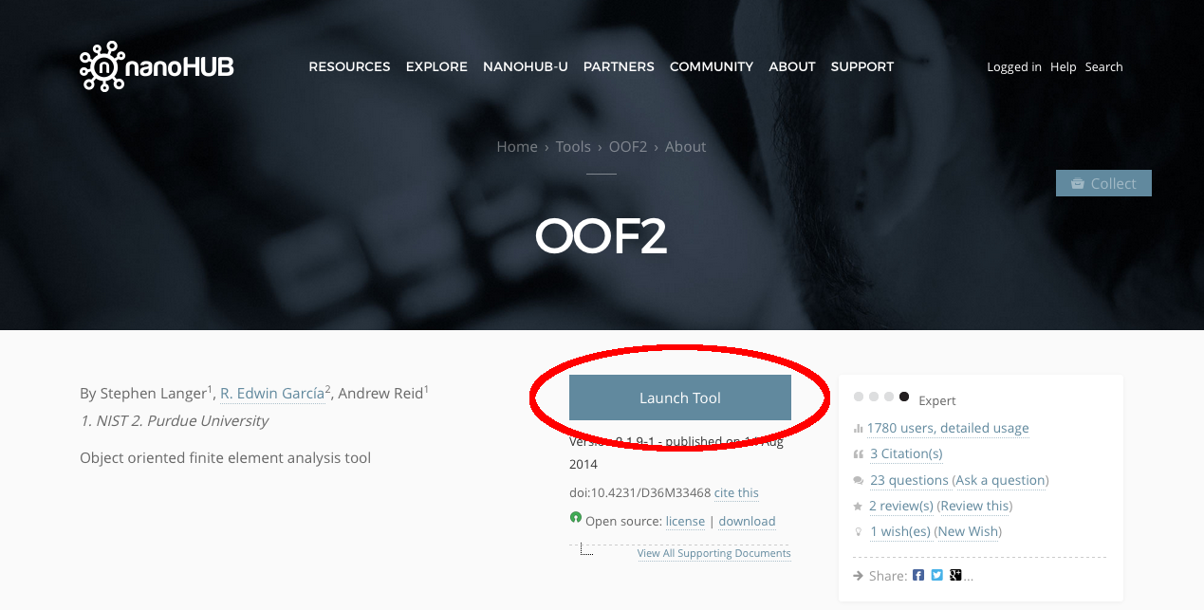

1.6 The main OOF2 window will appear in your web browser. (Make sure it looks like this, although the version number may be different.)

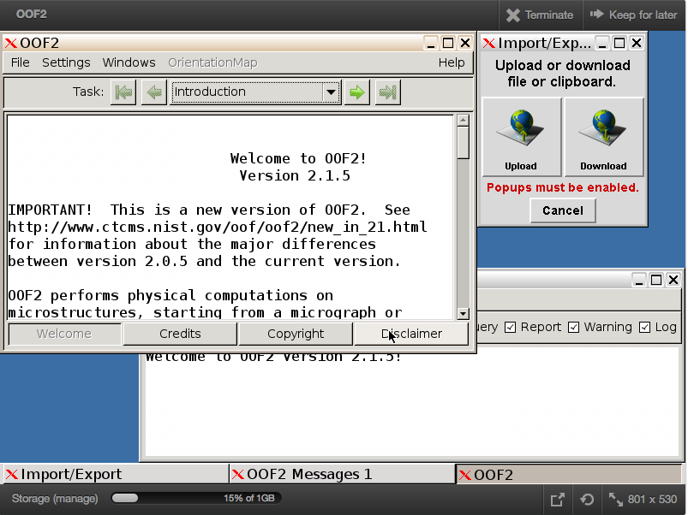

1.7 The first step will be to upload a simulated microstructure. We will use the file that was emailed to you, composite.ppm. The file contains an image of a composite that we will perform simulations on today. It looks like this:

which should be understood to be a 2D cross-section of a composite with two different phases.

1.8 To load the image into OOF2 on nanohub, first make sure any pop-up blocker in your web browser is turned off. Then click on the Upload button in the upper left of the OOF2 window.

1.9 In the window that opens, leave Upload a file selected, then click Choose File.

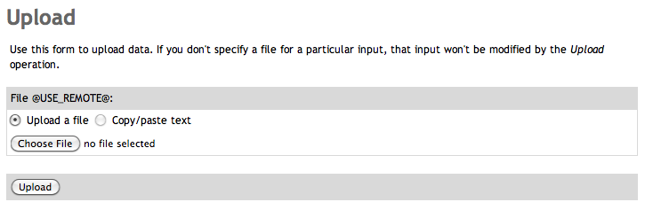

1.10 Navigate to where you saved the file composite.ppm and choose this file. Then when you are returned to the Upload window, click the Upload button. (If you do not see the new window, look behind other windows – it tends to hide behind!)

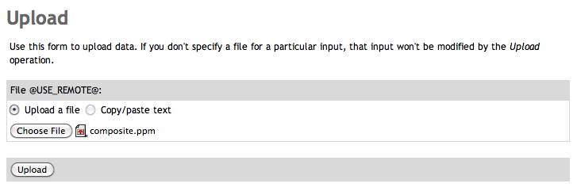

1.11 After the file is uploaded, you will return to the OOF2 window. Click on the arrow button next to the Introduction button to move to the Microstructure task pane. Click New from Image File.

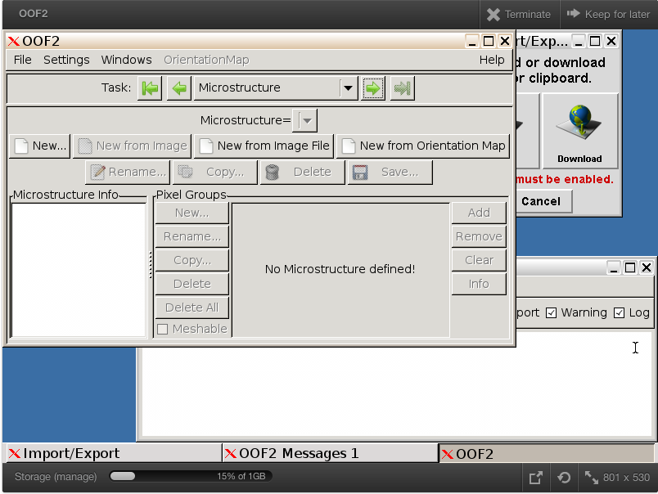

Note the pop-out option at the right bottom of the browser window, which pops out the java window outside of the web browser. This works better in some cases (e.g., when running nanoHub within a web browser blocks the view of the windows within the application).

1.12 In the Load Image and create Microstructure window that appears, choose the file composite.ppm. To set the height of the image in physical dimensions, click to the left of height and enter the height in meters. The width will automatically be calculated based on the aspect ratio of the image. Click OK.

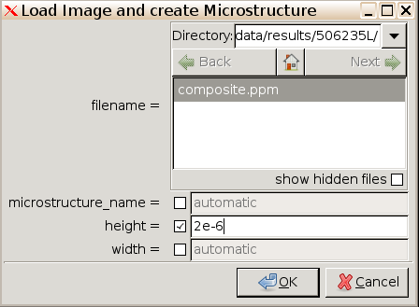

(By default, the file is uploaded into a new directory that is created when you start each new session, in this case called 506235L, which is the same as the session number. You can find the session number above the OOF2 window or in the URL of the page):

1.13 The Microstructure window will now contain new information about the image file you just uploaded.

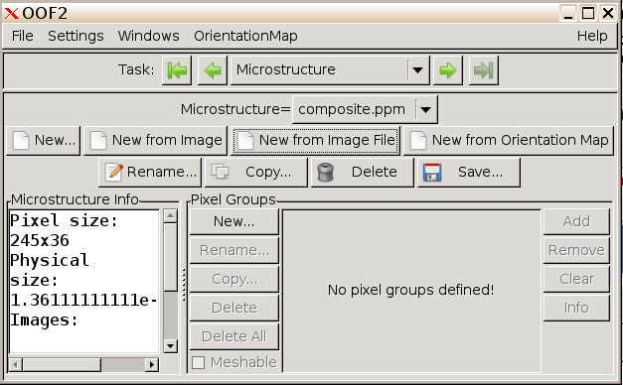

Find the Windows menu at the top of the main OOF2 window. Select "Graphics" from the popup and click "New". You will see a graphical display of the microstructure file that you just uploaded:

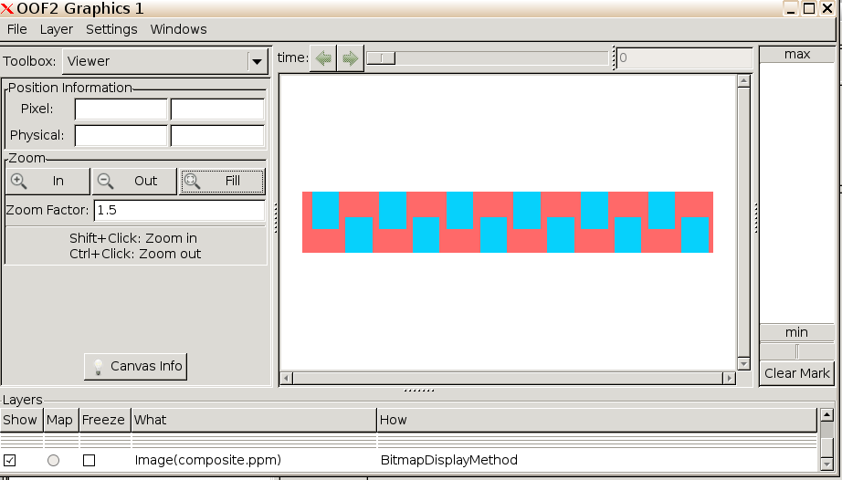

2. Assigning material properties
In this section, we will assign material properties by following these steps:

2.1 We begin by creating Pixel Groups, which is the first step to assigning material properties to each color in the microstructure image file. In the Graphics window, choose the Pixel Selection Toolbox from the upper left drop-down menu.

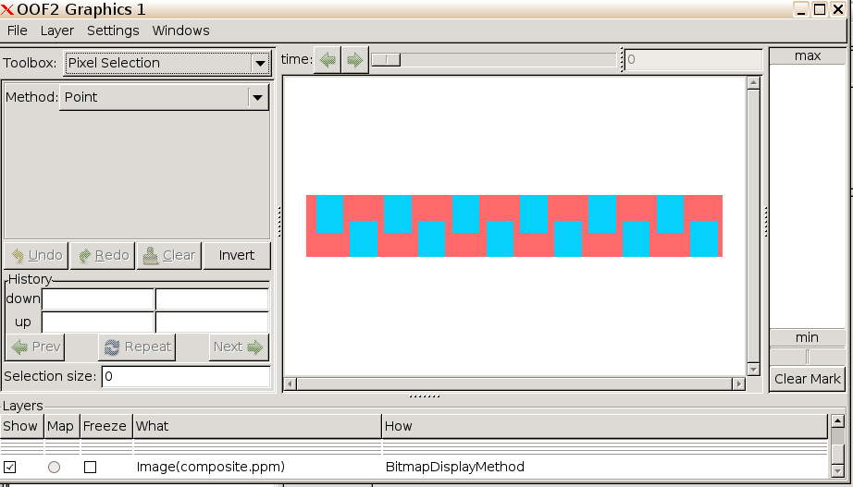

2.2 From the Method drop-down menu that appears below, choose Color. This will allow you to group all pixels in the image that have the same color. Click the “matrix” phase (red) region. It will change color slightly to indicate that it has been selected.

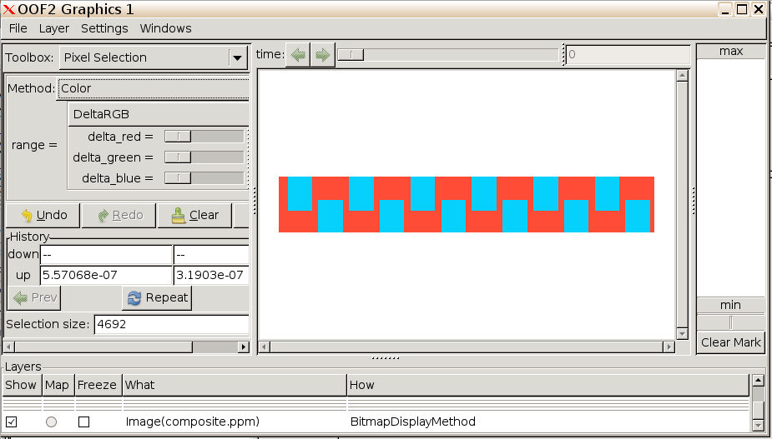

2.3 Now that the pixels have been selected, return to the Main OOF2 window where the Microstructure task pane is still active. Under Pixel Groups, click the New… button.

2.4 In the window that appears, click on the box next to Name and click in the text box, then type the name “middlegroup.” Then click OK.

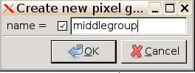

2.5 Back in the main OOF2 window, you will see that the new group has been added to the list on the lower right.

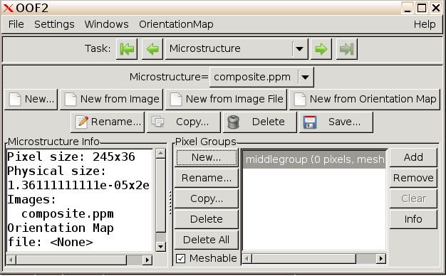

2.6 To add the pixels you selected in the Graphics window to the new group, click Add to the right of the list of Groups. The pixel count next to middlegroup should now give the count of pixels in the group, 4692. (If not, try going back to the Graphics window and selecting the middle region with the color tool again, and clicking Add again.)

2.7 Now select the blue pixels (the remainder) of the image, and add it to a new group called “edgegroup.” The easiest way to select this is to use “Invert” function below the “Color” function. You may have to resize the window to see the function button.

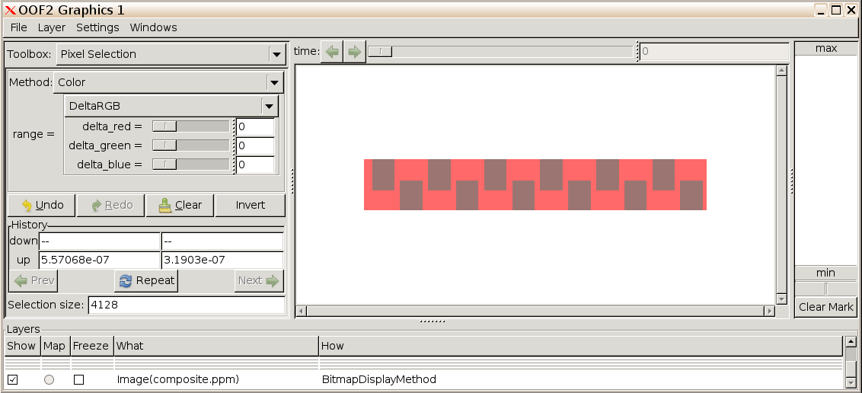

After addition of the additional pixel group, the Microstructure Task Pane should look as follows:

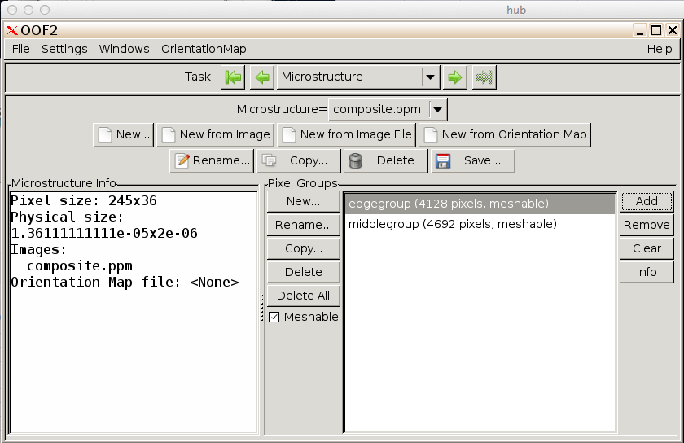

2.8 To begin specifying material properties for the pixel group, click the right arrow in the main OOF2 window several times to move to the Materials task pane, or click on the Task drop-down menu and pick Materials.

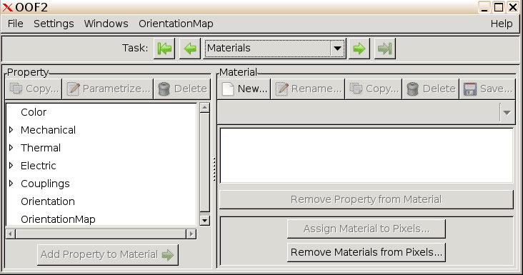

2.9 To create a new material, click New. The following dialog box appears.

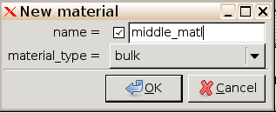

2.10 Click the box next to name, and click in the field next to it to give it a name, then type the name middle_matl. Leave the material_type as bulk. Click OK. Now create another material, which will be used for the blue fibers at the top and bottom of the microstructure. Call it edge_matl.

2.11 We are now ready to start assigning properties to this material. The properties we need to assign for this simulation are the isotropic elastic constants (Young’s modulus and Poisson’s ratio).

2.12 To create the Young’s modulus property, go to the Property pane at left. Click the triangle to the left of Mechanical, then click again on the triangle next to Elasticity, and click the word Isotropic.

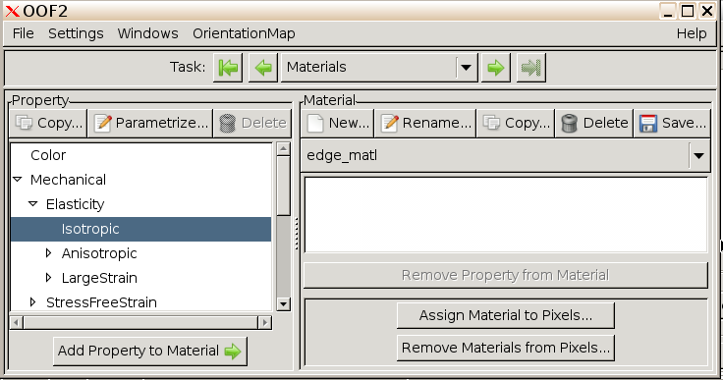

2.13 Click Copy… above the list of properties. In the dialog box that appears, click next to new_name and give it the name Young_middle.

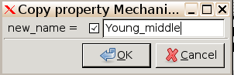

2.14 The new property will now appear in the list of properties under Mechanical->Elasticity->Isotropic.

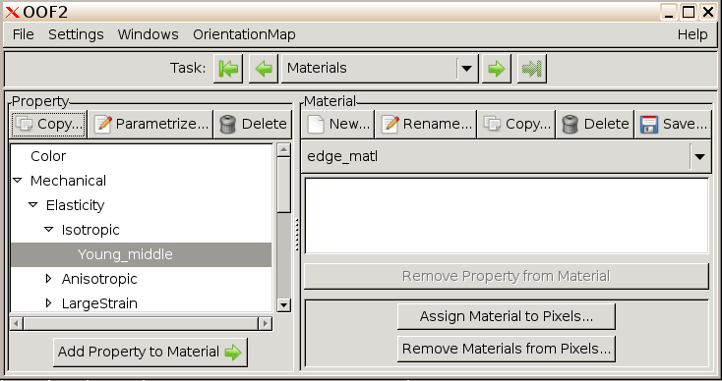

2.15 Now select Young_middle, and click Parametrize... The choices in the list
box are C_{ij}, Lame, E and nu, and Bulk and Shear. Select the
item E and nu. Set the value of Young to 50 GPa and leave Poisson at the default value of 0.333. Then click OK.

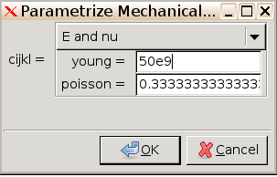

2.16 Repeat the process to create the following properties: Young_edge with Young=200 GPa and Poisson=0.3.

2.17 Once you have added these properties we need to attach the properties to each material. To do so, select the material you want to add properties to in the drop-down menu on the right side, then click to select the property you want to add to it. Then click Add Property to Material at the lower left.
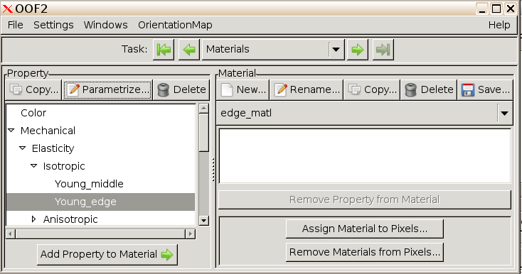

Make sure that the appropriate mechanical properties are assigned to each material.

2.18 Finally, assign each material to one of the pixel groups you have created. With middle_matl selected in the drop-down list, click Assign Material to Pixels…

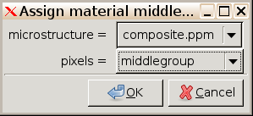

Choose middlegroup from the drop-down list. Repeat this process to assign edge_matl to edgegroup.

At this point, you should have completed these steps and have these properties linked with each group of pixels:

3. Creating a finite-element mesh

3.0 Before beginning the mesh generation. It may be helpful to change the behavior of OOF2’s undo function for the skeleton so that it uses less memory. This will potentially make the tool more stable. In the main OOF2 window, click on Settings > UndoBuffer Size > Skeleton… and then change the value to between 0 and 5 depending on how comfortable you are with generating the skeleton.

3.1 The first step in creating a FE mesh is to create a skeleton, which the mesh will inherit its basic properties from. Click the right arrow to advance to the Skeleton task pane. To create an initial skeleton, click New… In the dialog box that opens, set x_elements to 60 and y_elements to 10. Change the skeleton type from QuadSkeleton to TriSkeleton, and change arrangement to Moderate. Click OK.
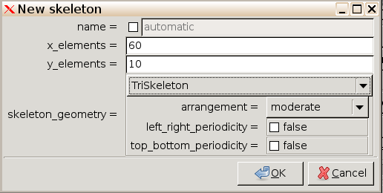

3.2 If you go back to the graphics window, you will see the skeleton overlaid on top of the microstructure.

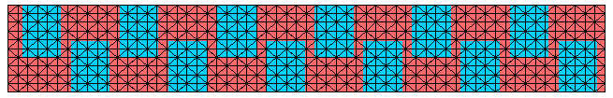

3.3 The above skeleton will not be fine enough to accurately resolve the strain distribution in this microstructure; notice that there are numerous triangles with 2 materials inside, and there are too few points near corners, where the distributions may have large variations. To improve the resolution of the skeleton, there are several tools under the title Skeleton Modification. In the next several steps we will use the methods anneal, swap edges, smooth, swap edges, anneal, swap edges, anneal, refine, swap edges, anneal, and refine in that order to improve the skeleton. First try the method Anneal, which is a way to make the grid more homogeneous and the triangles more equilateral. Set the average energy criteria α to 0.8 and iterations to 30. Click OK to anneal.

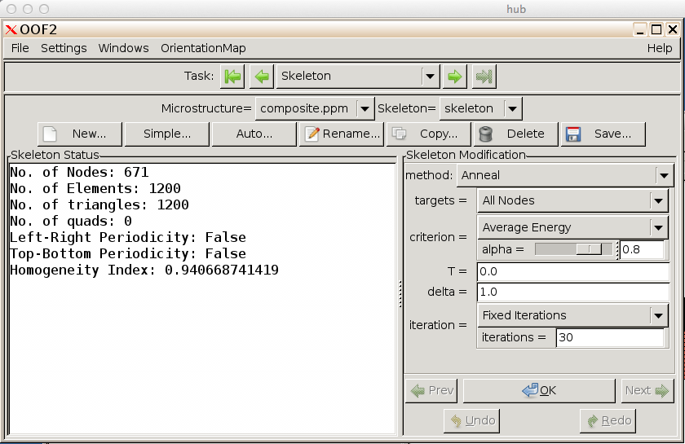

3.4 If you zoom in and look at the skeleton now, you can see that the edges of the triangle now line up much better with the phase boundaries, except at the far left. Your skeleton may vary from this image because annealing does not always give the same result.

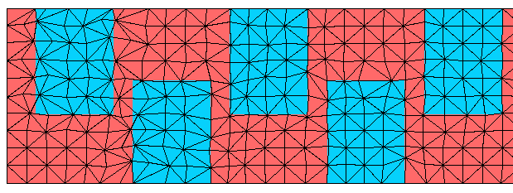

3.5 Next try Swap Edges, this will also help to better align the skeleton points with the phase boundaries. Under Skeleton Modification, choose Swap Edges and use the α=0.8. Then click OK.

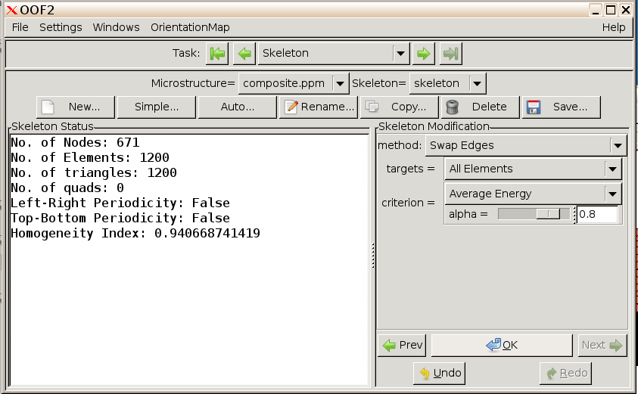

3.6 Now try a smoothing step, which will readjust node positions to decrease energy. Use α=0.8 and 25 iterations. Click OK.

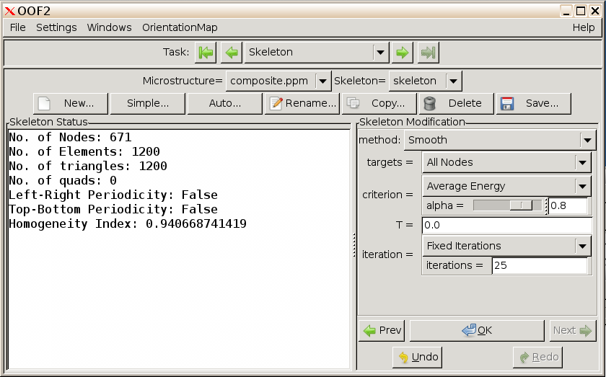

3.7 Now use Swap Edges again using the same parameters. Anneal again with α=0.8 and 25 iterations. Then do Swap Edges and Anneal again with the same parameters. If you look back at the skeleton you will see that the skeleton is looking better, especially at the far left.

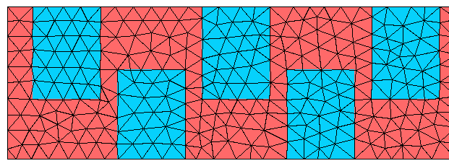

3.8 Although the skeleton is looking better, there are still too few elements at the edges and between the adjacent composite phases. To help with this, use refinement. Set method to Refine, targets to All Elements, and degree to Bisection with rule_set liberal, and α=0.8.

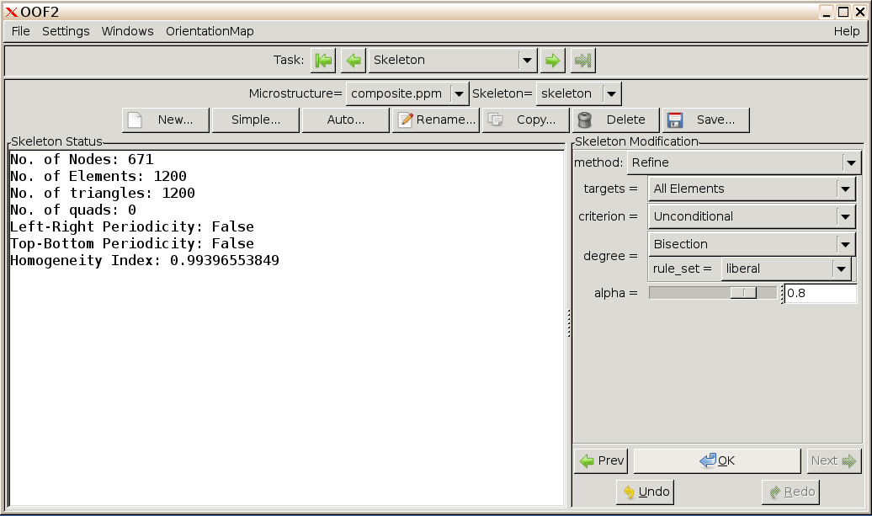

3.9 Swap edges then anneal, then refine again with the same parameters. You will see that the number of elements has grown significantly.

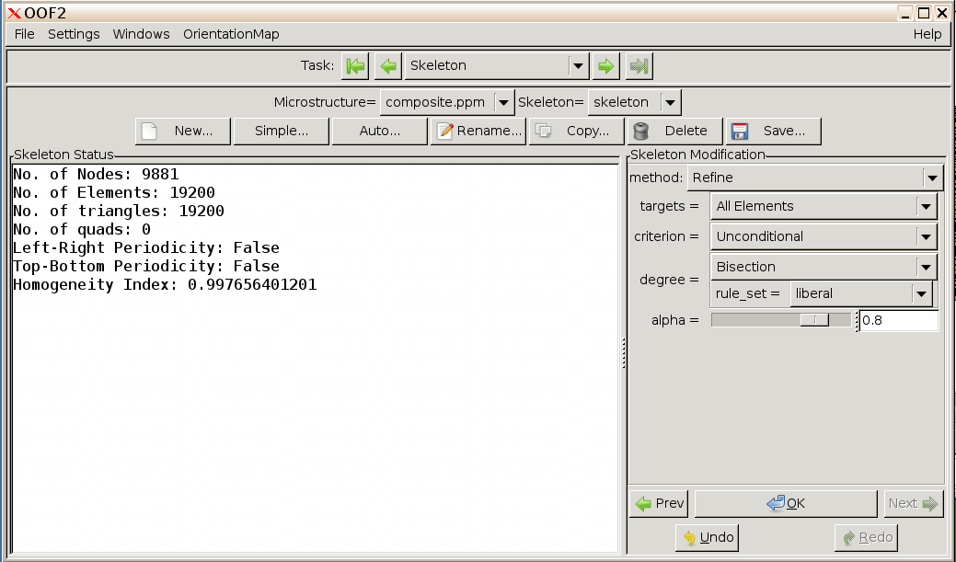

3.10 The skeleton now looks as follows:

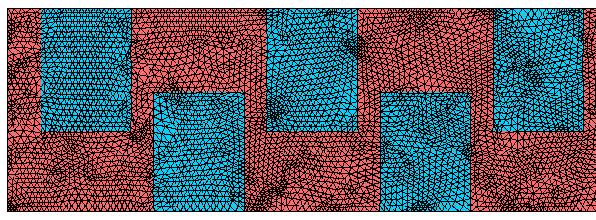

3.11 To create a mesh, Click on the Task drop-down menu to move to the FE Mesh task pane.

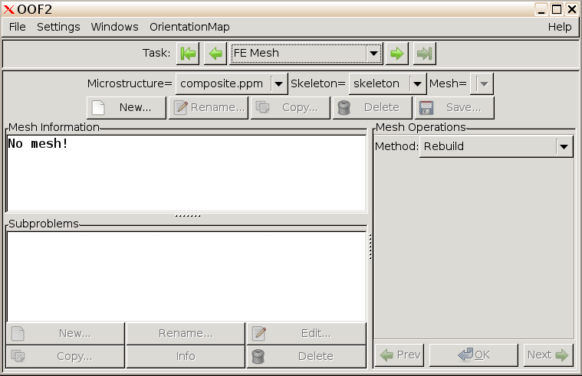

3.12 Click on New… A dialog box will appear which will allow you to create a new mesh, which is based on the skeleton that you have already created and refined. For a more accurate calculation you would normally set mapping order to 2 and interpolation order to 2, which increases the number of nodes per element. For demonstration purposes the calculation will be much faster if you leave the default values of 1 and 1 set. Click OK.

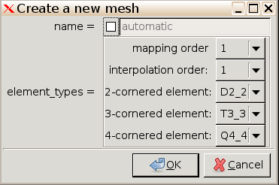

3.13 You will now see details of the mesh under the Mesh Information heading.

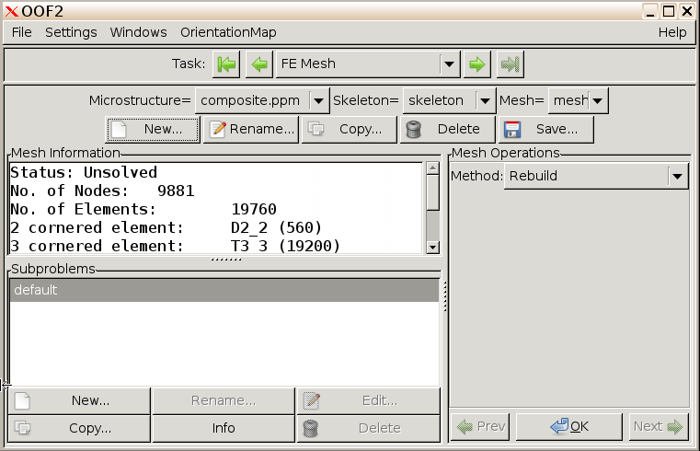

4. Setting equations and boundary conditions

4.1 Click the right arrow or click the drop-down menu to move to the Fields & Equations task pane. Check the boxes to the right of Displacement, as well as the box next to active. On the right-hand side, check that you want to solve the Force Balance equation in a plane stress condition.

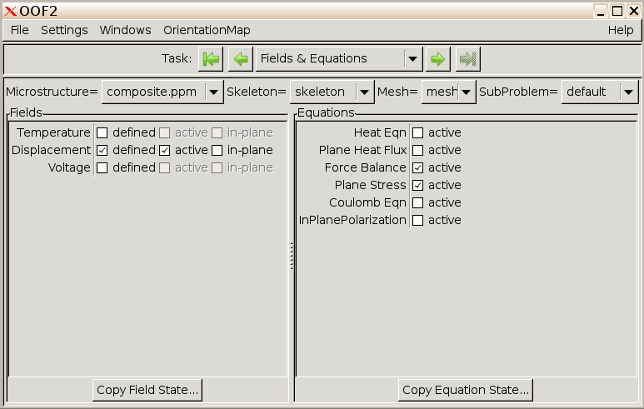

4.2 Next click the right arrow to move to the Boundary Conditions task pane. Under condition, click New…

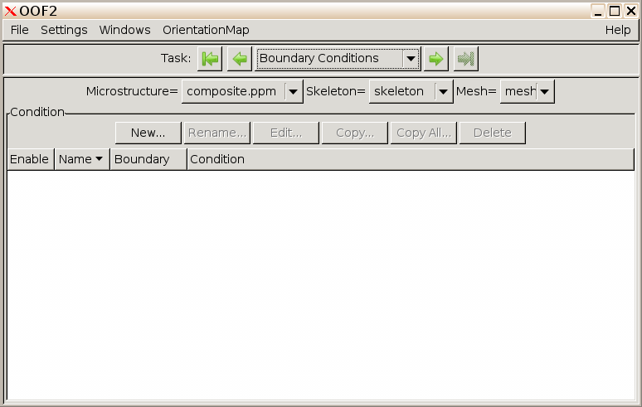

4.3 To strain the system in the y-direction, we will first “clamp” the bottom by setting a boundary condition that displacement in the x and y directions are zero at the bottom. Set the boundary condition to Dirichlet, the field to Displacement, field_component to x, equation to Force_Balance, eqn_component to x, profile to Constant_Profile, value to 0.0, and boundary to bottom. Click OK. To set the bottom boundary condition, click OK again and set the same parameters, except in the y-direction.

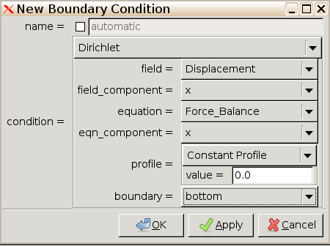

To set the top boundary condition, assume we want to apply a 1% strain. We will apply a displacement in the y-direction equal to 1% of the height of the sample, or 2×10⁻⁸ m. (Set both field_component and equation_component to y in setting this condition. Anchor the bottom and use displacement value at the top such that you obtain 1% strain.)

You will see the boundary conditions you have defined in the Boundary Conditions task pane.

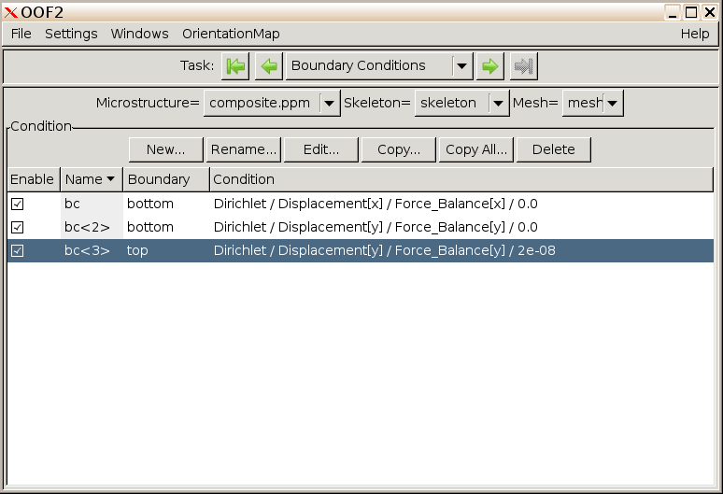

4.4 Pick the Solver task pane from the drop-down menu. This pane allows you to select the type of solver and parameters used to solve the force balance equation on the finite element mesh. Double-click on the first line under Solvers to set up how to solve the equations.

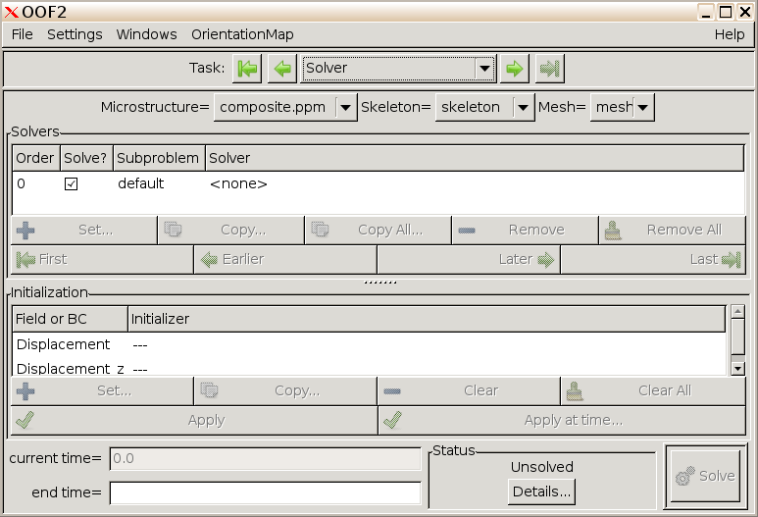

4.5 You can leave the solver set to the Basic mode, which will allow OOF2 to choose how to best solve the problem numerically. If you have more experience with numerical solutions, you can set solver_mode to Advanced and choose what kind of solver, matrix preconditioner, etc. manually. Click OK.

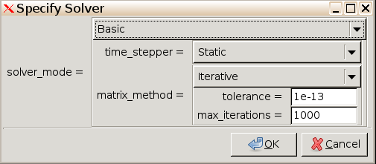

Back in the Solver task pane, click Solve. The solution will take a few minutes.

Now we can look at the solution of the deformed material. The mesh after the solution is superimposed on the original skeleton and microstructure image in the Graphics window.

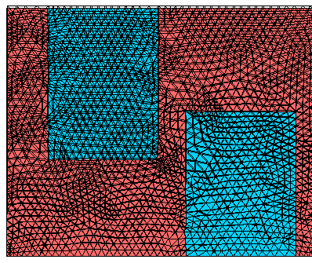

4.6 It will be easier to see if you hide the original skeleton. To do this, in the Graphics window, scroll down in the list of Layers at the bottom. Uncheck the box to the left of Skeleton. The display of the deformed mesh should now be clearer.

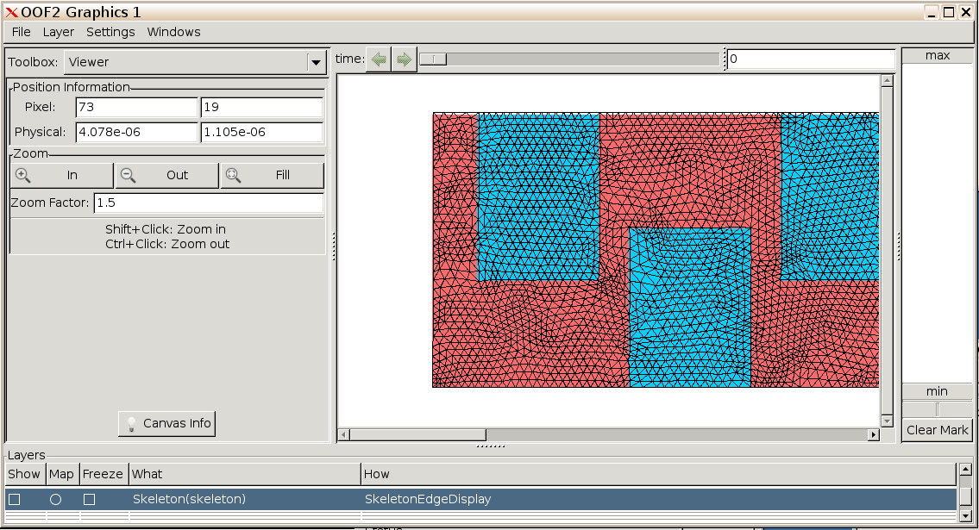

4.7 To see the stress distribution in the composite, go to the Layer menu and choose New…

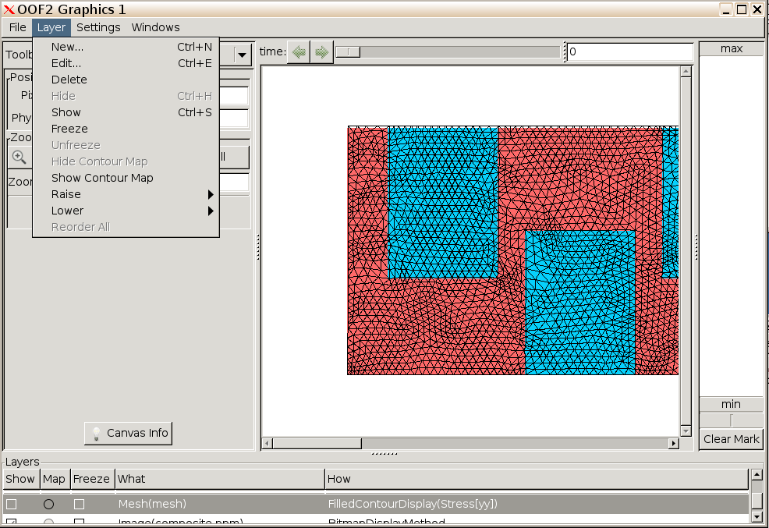

4.8 Underneath Displayed Object, pick Mesh in the list next to category. Under Display Methods, pick New…
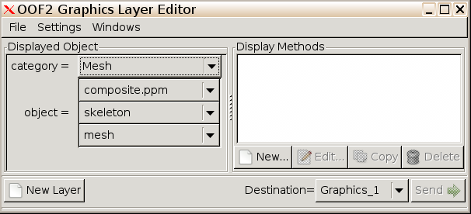

4.9 Pick Solid Fill in the drop-down menu, and select the Flux, Component, Stress, and yy for What. Next to Where, pick actual. Set levels to 20. Click OK.

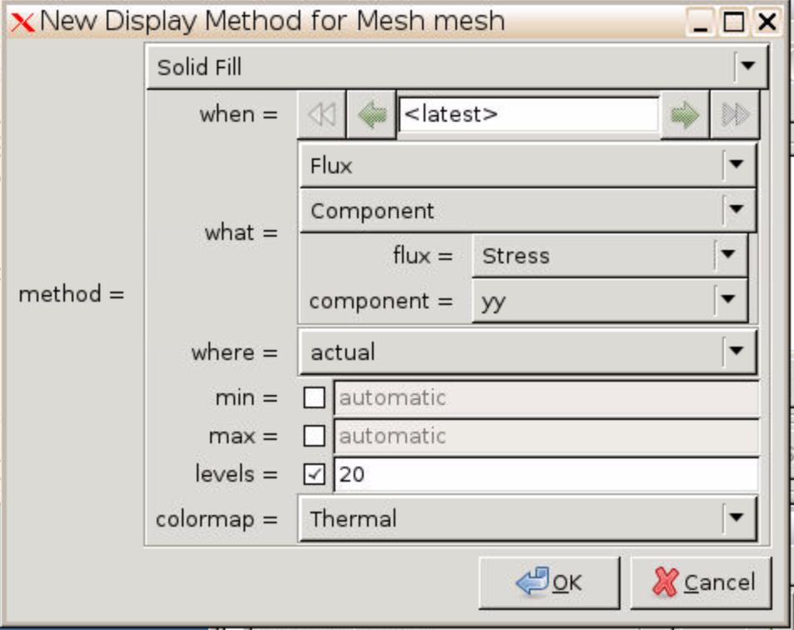

In the Graphics window, you will see a contour plot of the stress profile overlaid on the deformed microstructure (it will take a minute or so to generate the contour plot).

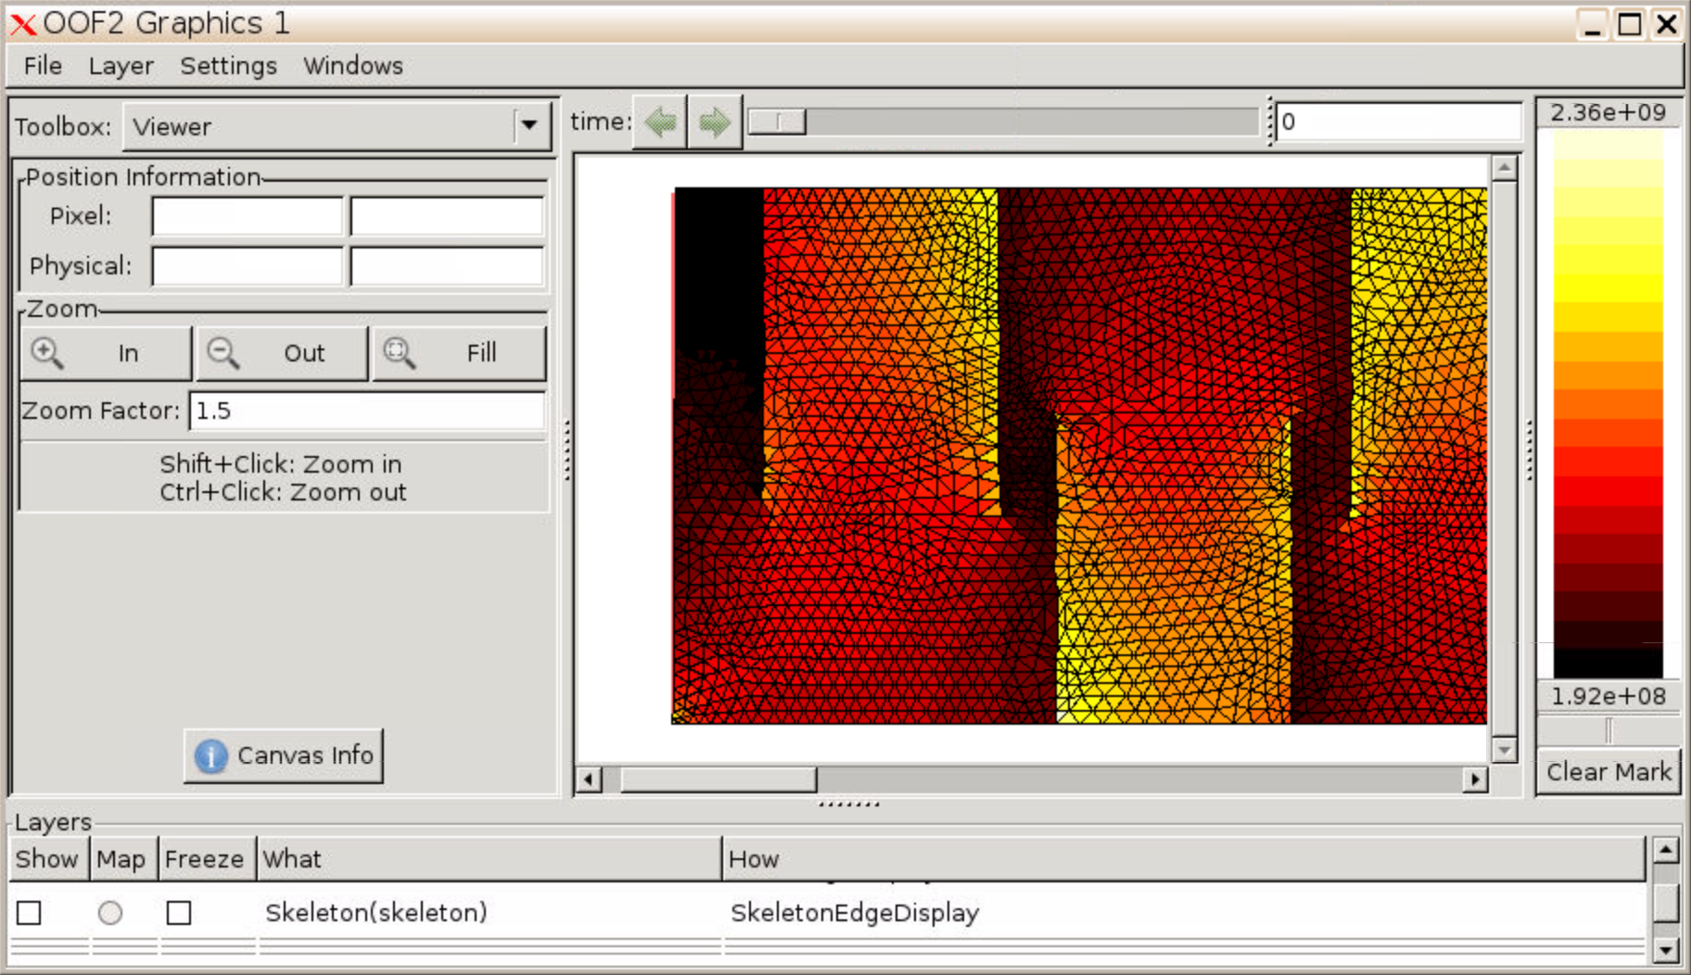

5. Analyzing results

5.1 To get more quantitative information about the simulation results, click the right arrow to move to the Analysis task pane. Here you can get more quantitative information about the calculations you have done. For example, you can output the average σ_{yy}. In the Output section, select Flux, Component, and set flux to Stress and component to yy. Then click go.

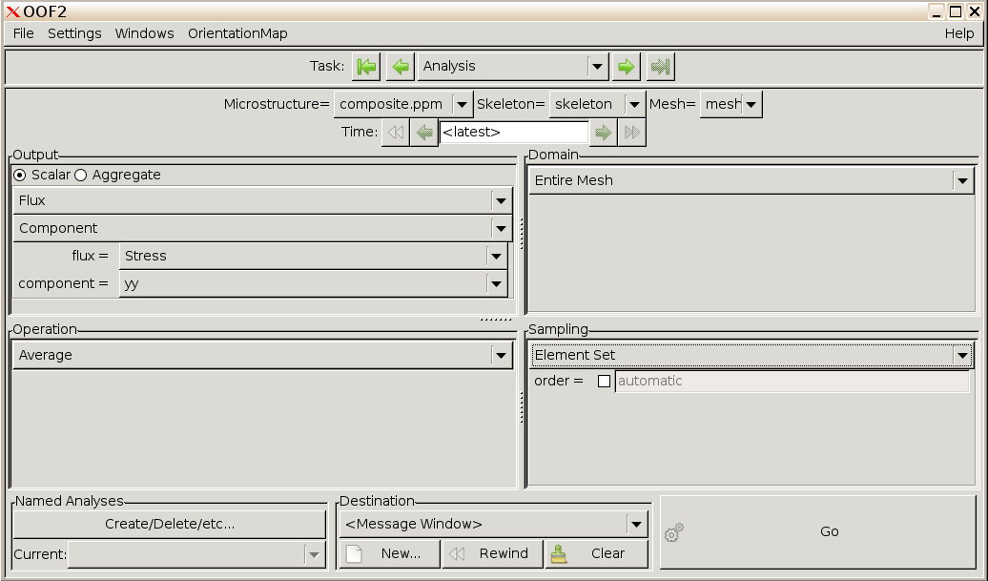
≈ç

≈ç
≈ç
≈ç

5.2 In the Message window, you will see the average stress. It may differ slightly from the number below.

