**Kinetics Module Walk-Through**

This walk-through demonstrates how to use a FiPy script to solve the diffusion equation as applied to the diffusion of dopant atoms in a silicon wafer.

**1. Uploading the script file**

* 1. In your web browser, go to nanohub.org. Click on the *Login* button in the upper-right hand corner.  
       
     
  2. Log in using your nanohub username and account.
  3. Click the *Search* button in the upper-right hand corner and type “vkml” into the search box.



* 1. Choose The Virtual Kinetics of Materials Laboratory from the list of search results.  
     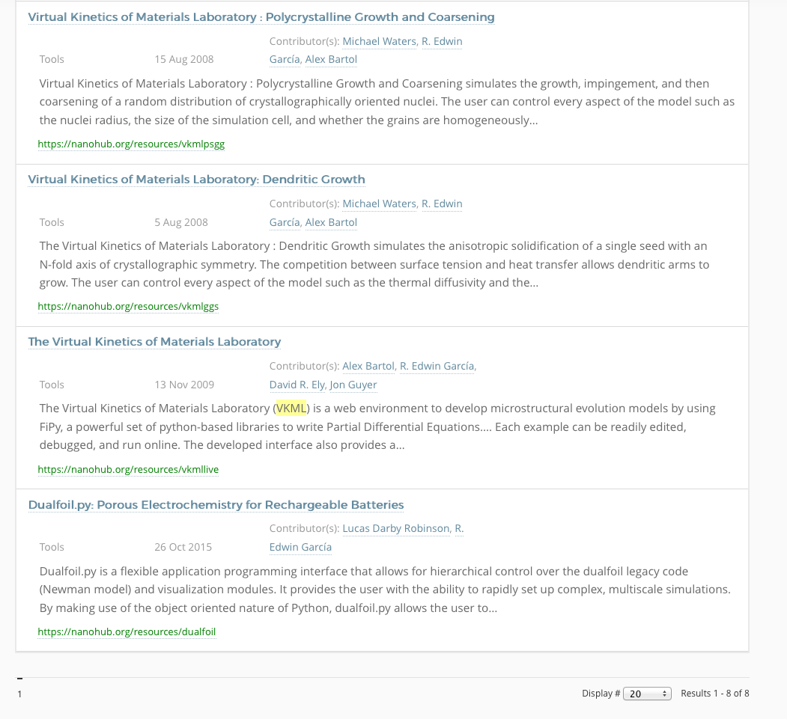
  2. Click *Launch Tool* from the VKML page.  
     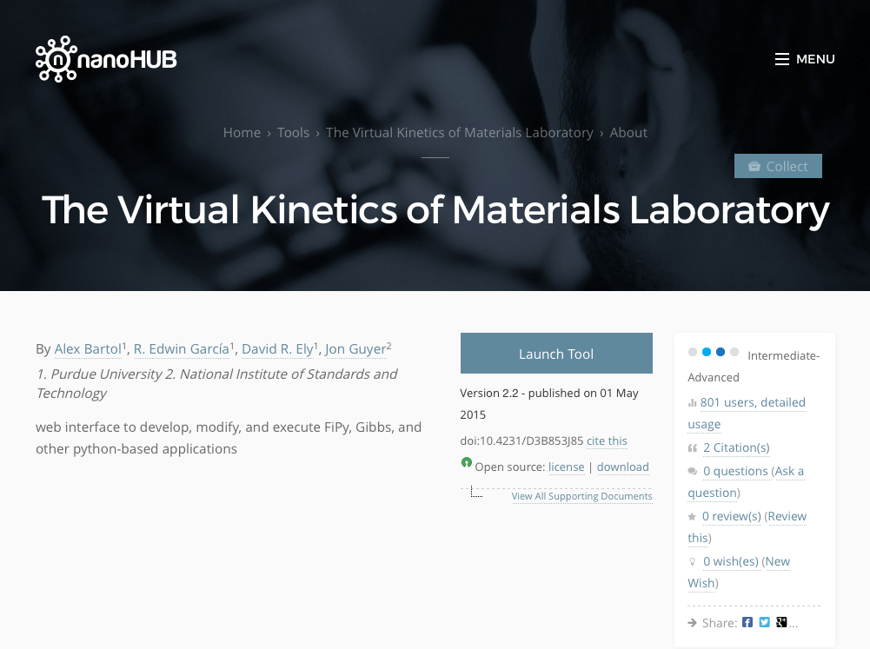
  3. The main VKML window will appear in your web browser. Make sure the window contents are as shown below (appearance may differ slightly).

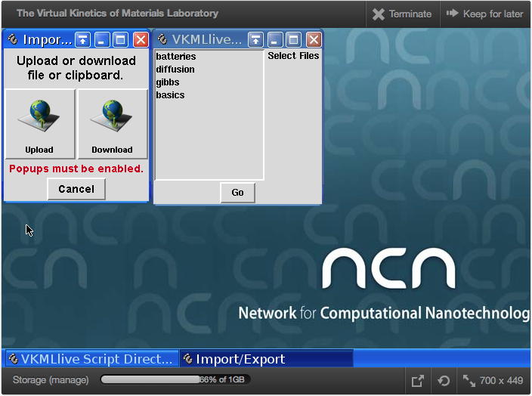

* 1. The first step will be to upload a sample script to use as a starting point. To load the script into VKML on nanohub, first make sure any pop-up blocker in your web browser is turned off. Then click on the *Upload* button in the *Import/Export* window.



* 1. In the window that opens, click *Browse*.  
     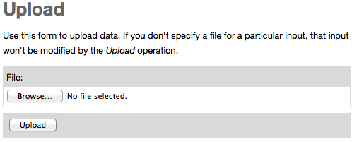
  2. Navigate to where you saved the file Diffusion_1d.py and choose this file. Then when you are returned to the Upload window, click the *Upload* button.  
     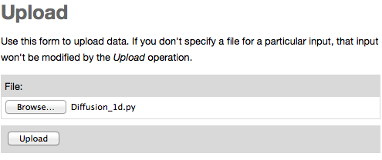

1. **Opening and running the script file**
   1. After the file is uploaded, you will return to the VKML window. Launch the VKMLlive tool by clicking *Go*.   
      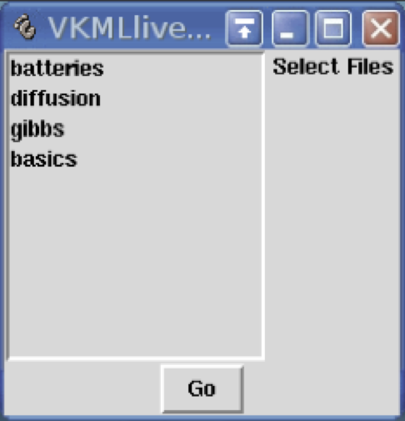
   2. To load the script you have just uploaded into VKML, choose *Open* from the *File* menu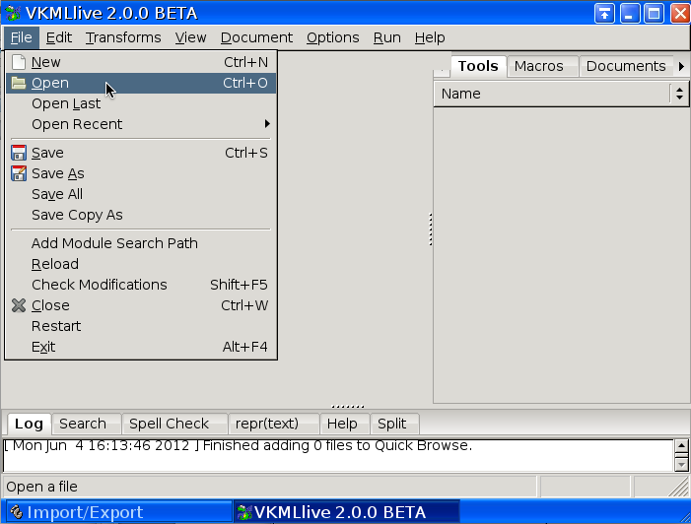
   3. In the open dialog box that appears, choose the file Diffusion_1d.py by clicking on it, then click Open.

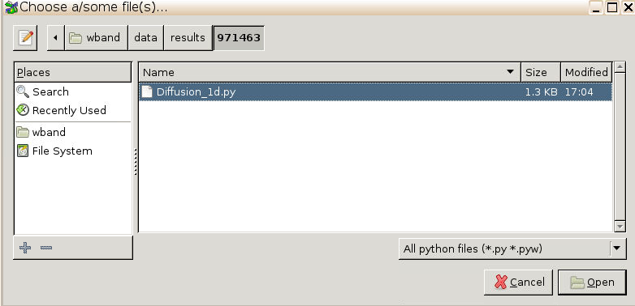  
(By default, the file is uploaded into a new directory that is created when you start each new session, in this case called 971463, which is the same as the session number. You can find the session number above the VKML window):  


* 1. You will see the script file you just opened in the editor pane. The display includes three panes, two of which are not useful right now. Maximize the editor pane by dragging the separator bars to the edges of the windows.  
     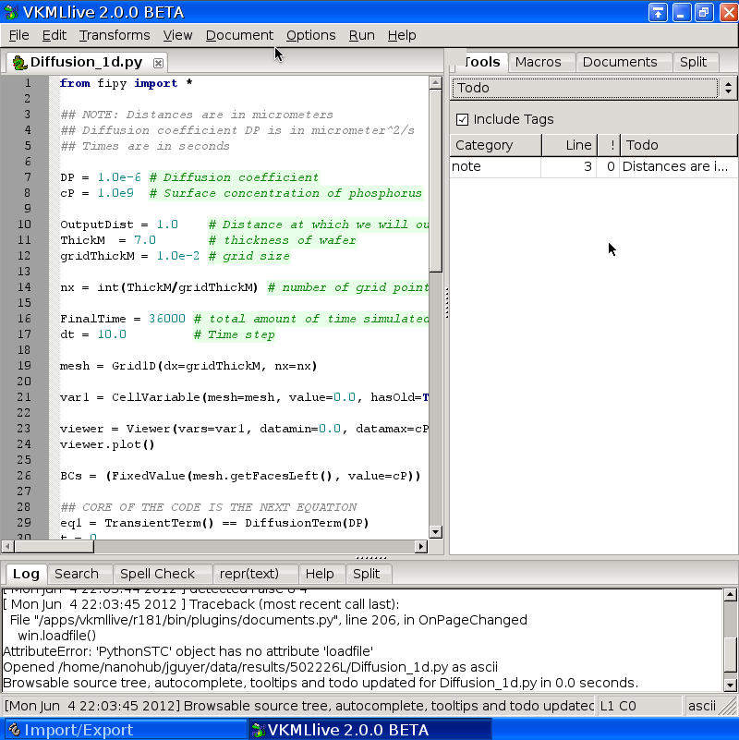
  2. To run the code, select *Run Program* from the *Run* menu.  
     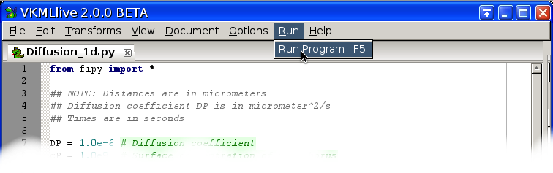 Two windows will open: a text window that shows messages from print statements, and a graphics window that shows the concentration profile as a function of distance.  
     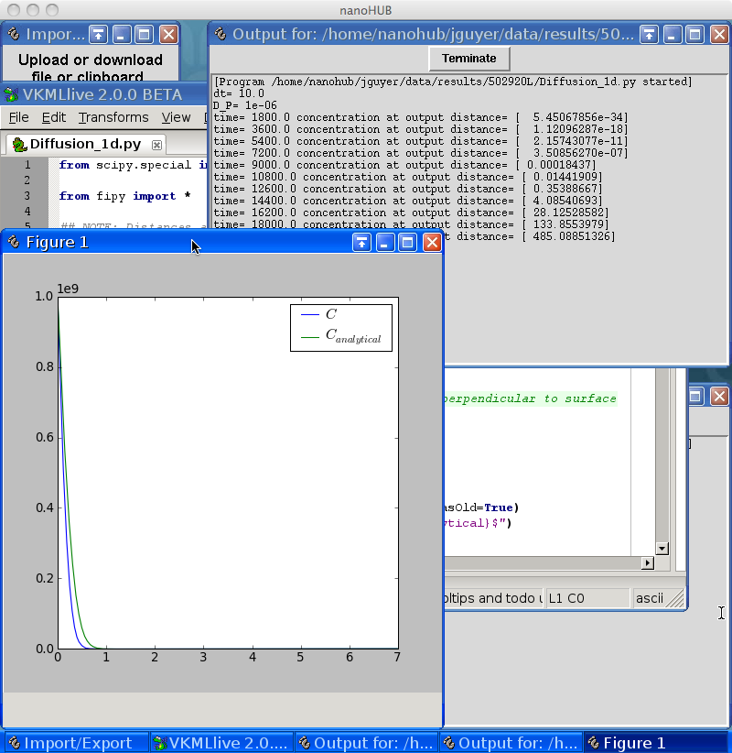
  3. The basic sections of the code are described below:
     1. FiPy setup

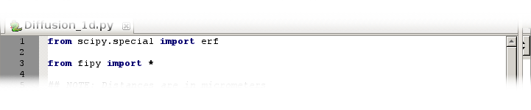

* + 1. Physical constants  
       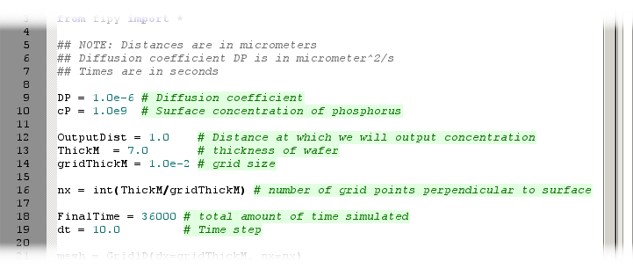
    2. Domain, solution variable and initial condition  
         
       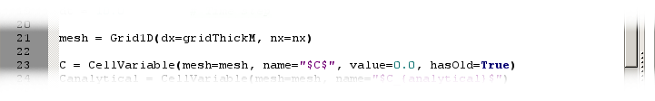
    3. Analytical result for comparison  
         
       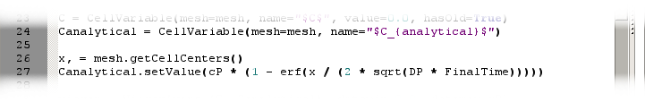
    4. Viewer to plot results  
       
    5. Boundary conditions  
          
       
    6. Equation definition  
         
       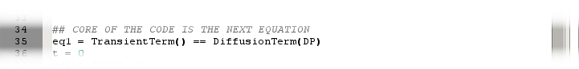
    7. Main loop to solve the diffusion equation as a function of time

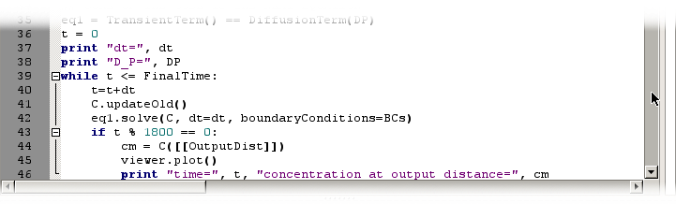

* 1. To change the thickness of the wafer in your simulation, modify the parameter ThickM. Change it to a value of 2.0 μm.  
     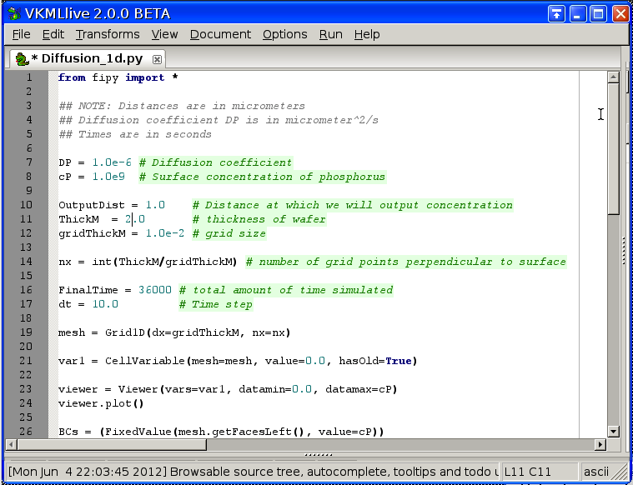
  2. Save the script by choosing *Save*from the file menu, then select *Run Program* from the *Run* menu.   
     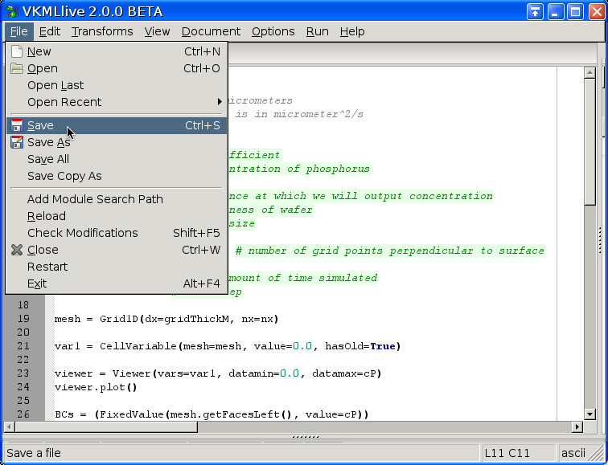You will now see that the concentration plot is different.  
     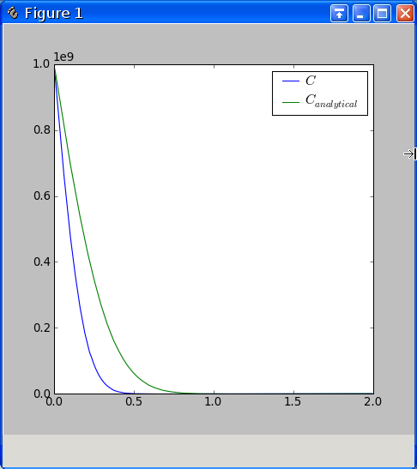
  3. You can also modify other parameters such as the time step, distance at which the concentration is output to the text window, and so on by modifying other parameters.  
     
  4. You can save your results by either storing images or raw data.   
     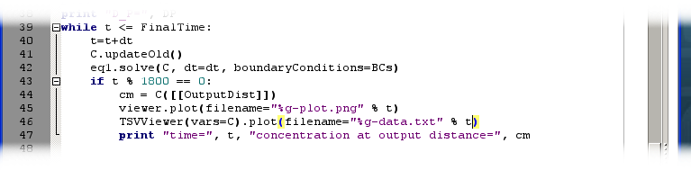
  5. After selecting *Save* from the *File* menu and *Run Program* from the *Run* menu, you can click the *Download* button in the *Import/Export* window  
       
       
     and then choose the desired files, *one at a time*, from the selection dialog  
     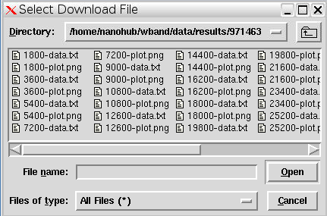  
     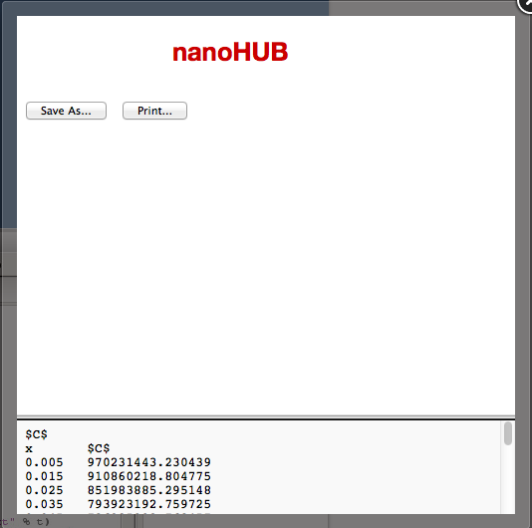 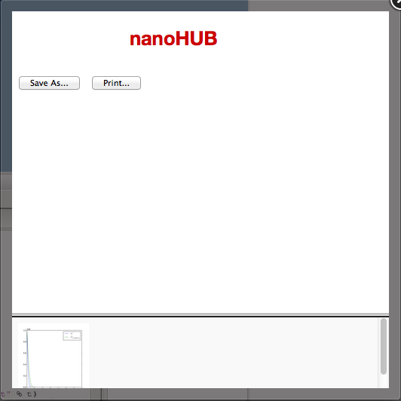
  6. You will need to perform a 2D simulation for the homework assignment. The code for this simulation has also been provided and is called Diffusion_2d.py. You can upload it using the same steps as in Section 1.

1. **Resources**

To learn more about the underpinnings of VKML:

* 1. Python  
     [www.python.org](http://www.python.org)  
     a powerful and easy-to-learn Open Source programming language

[www.diveintopython.net](http://www.diveintopython.net)

a nice tutorial

* 1. NumPy & SciPy

numpy.scipy.org & www.scipy.org  
an Open Source set of tools for numerical and scientific operations, similar in capabilities to Matlab

* 1. FiPy  
     [www.ctcms.nist.gov/fipy](http://www.ctcms.nist.gov/fipy)  
     an Open Source numerical PDE solver with lots of examples