Thermo-Calc Module Walk-Through

1. Calculation of the Fe-Cr Phase Diagram

1.1 After Thermo-Calc is opened (or if you click new) you will see this screen.

1.2 Click the Phase Diagram Template
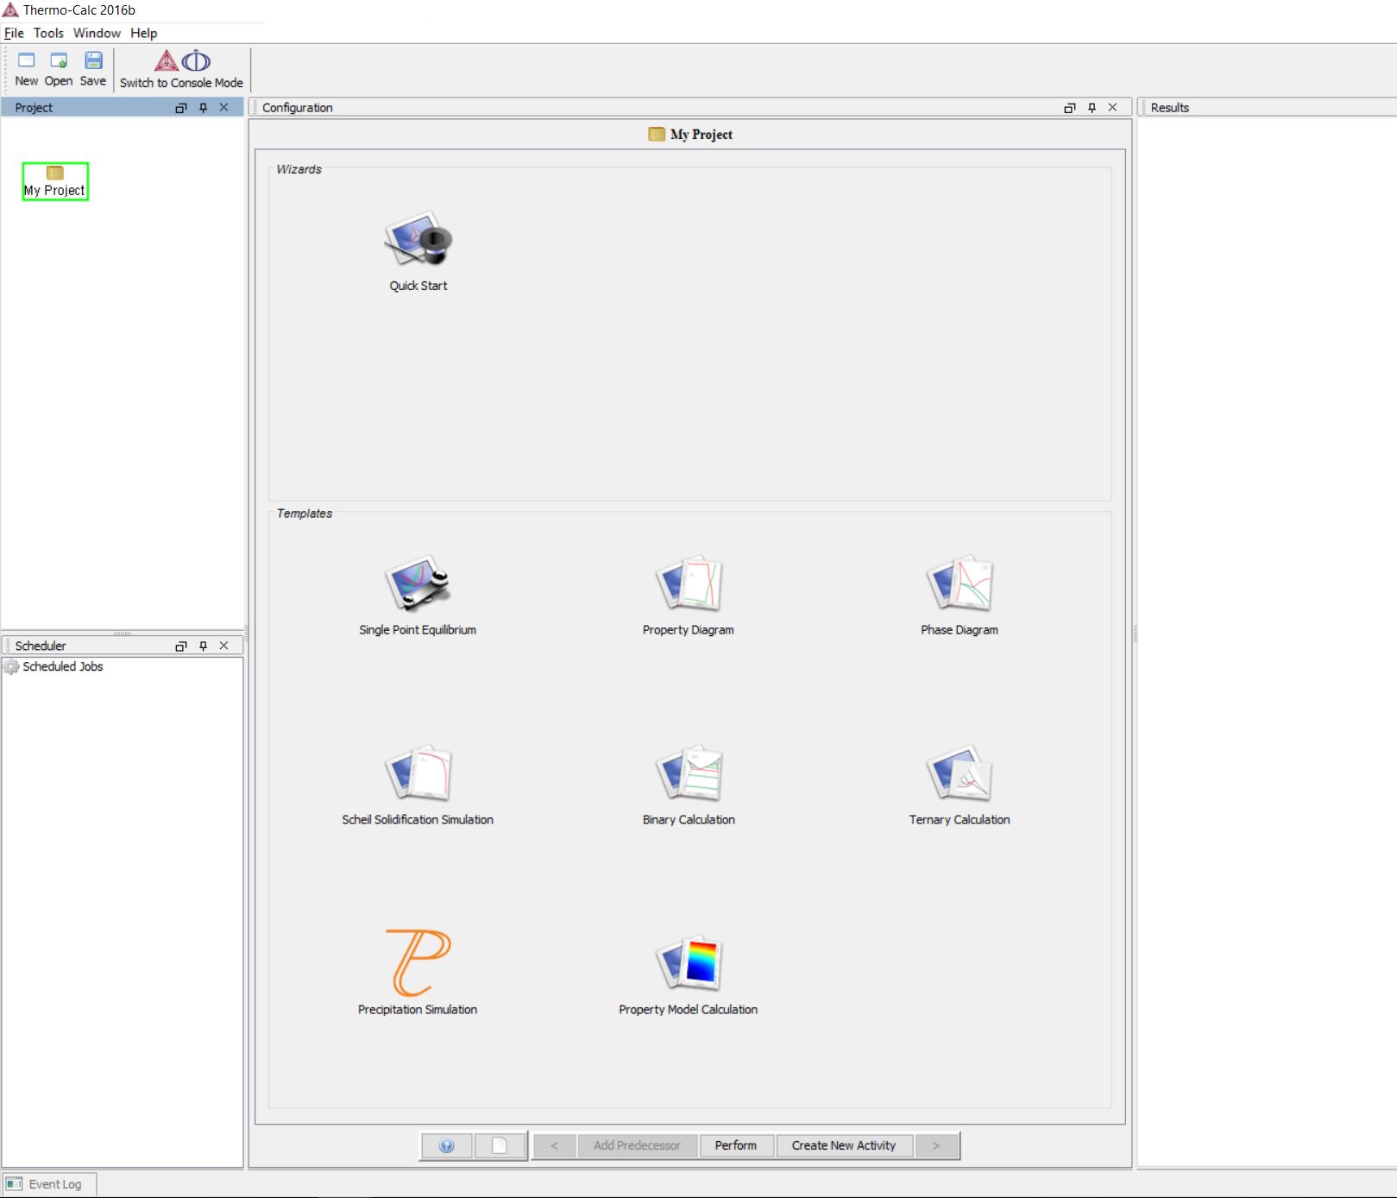

1.3 Select the elements Fe and Cr from the periodic table.
1.4 Click next ( > ).
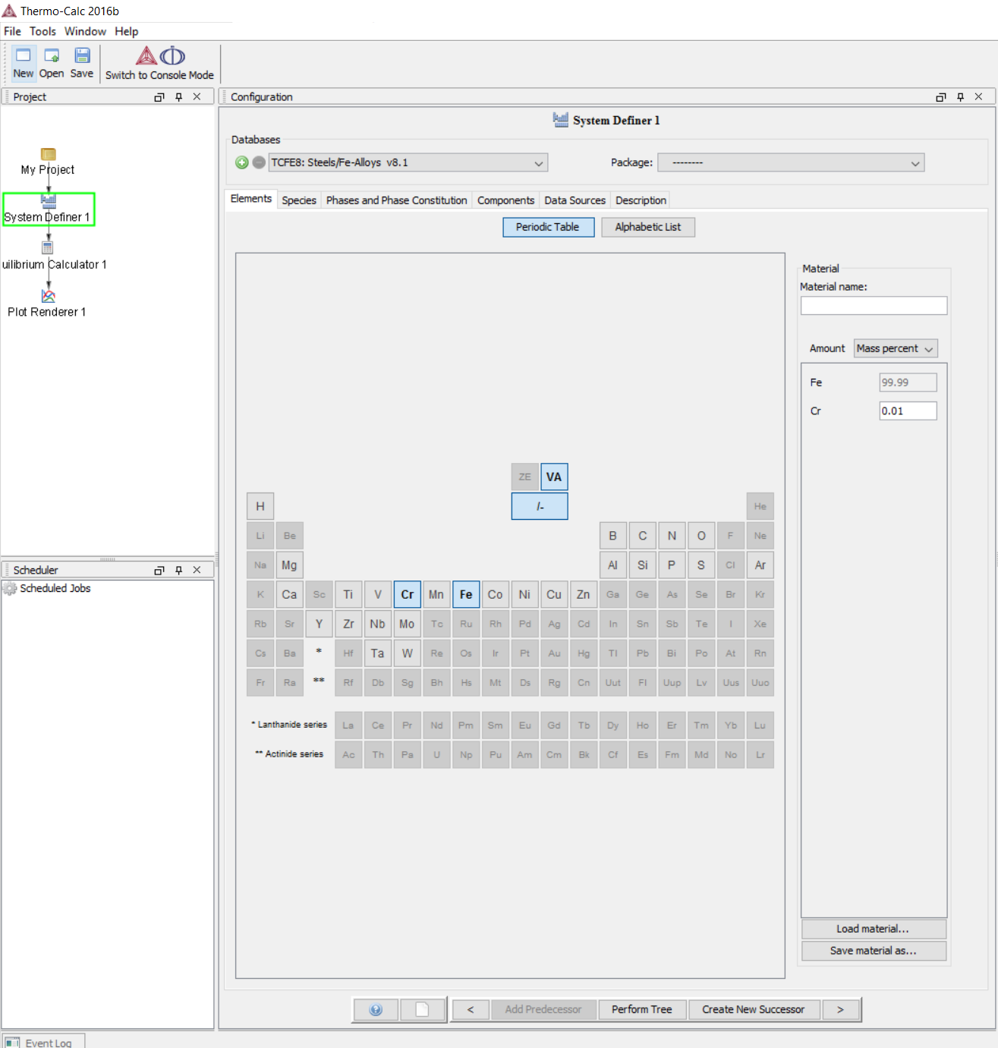
1.5. We can change other details for the phase diagram (such as pressure, etc), but for now let's leave it on default and click next ( > ) 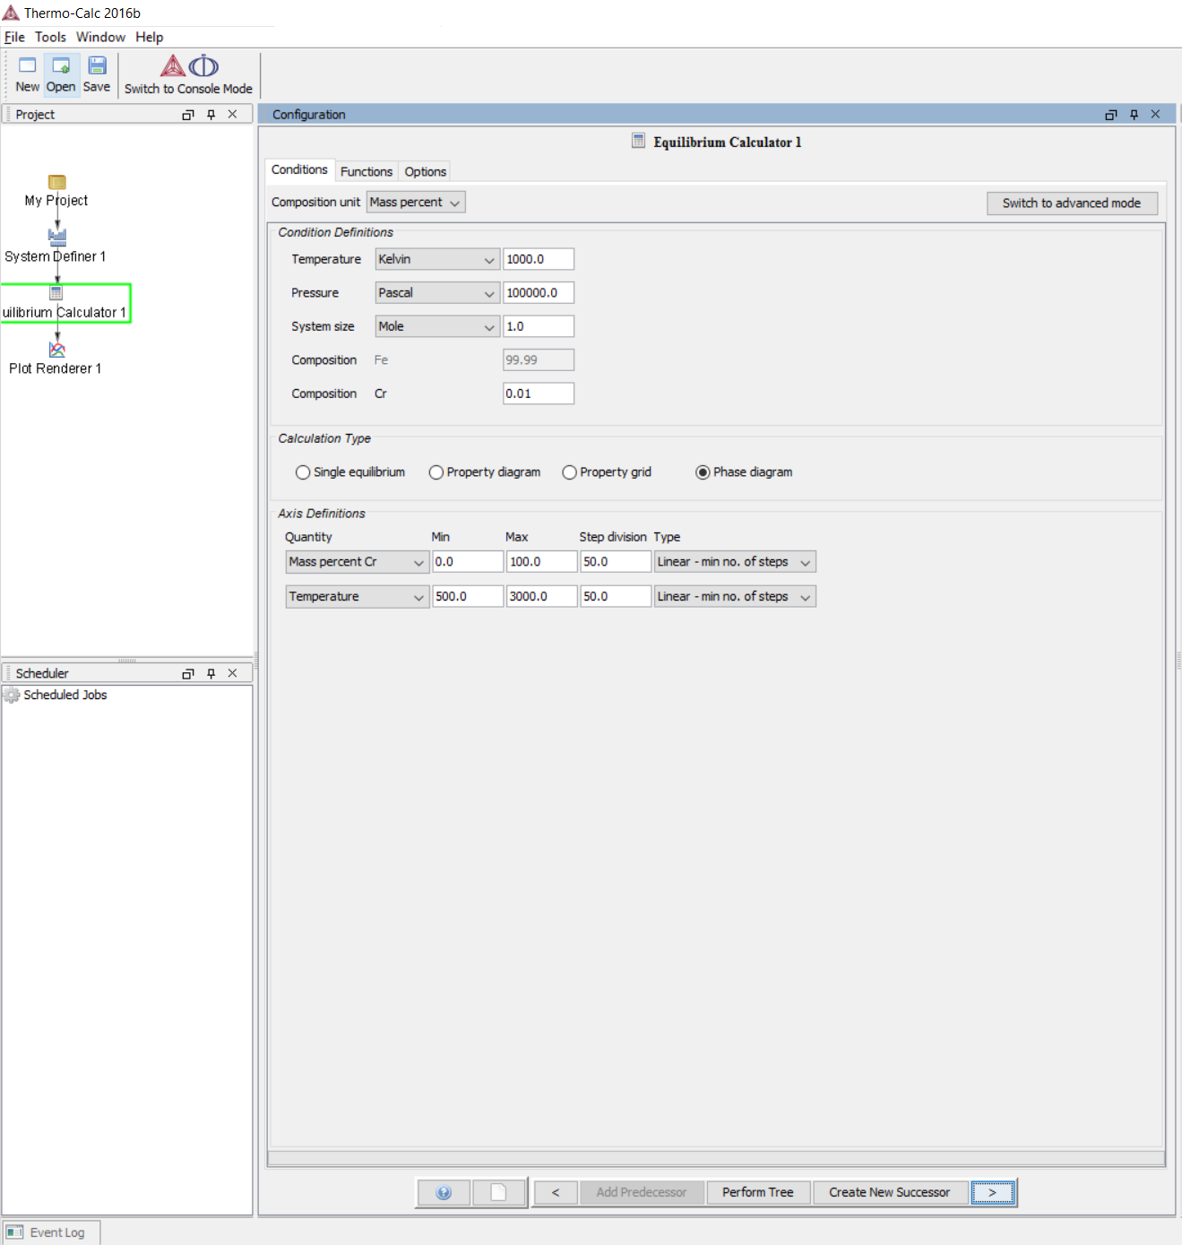

1.6. Finally, we can set the axes for our phase diagram, for now, let's leave it at default, or if the default in your screen is different from here, make sure you adjust the settings so they will be the same. Make sure the legend option is set to Axis quantity. After everything has been set, click Perform
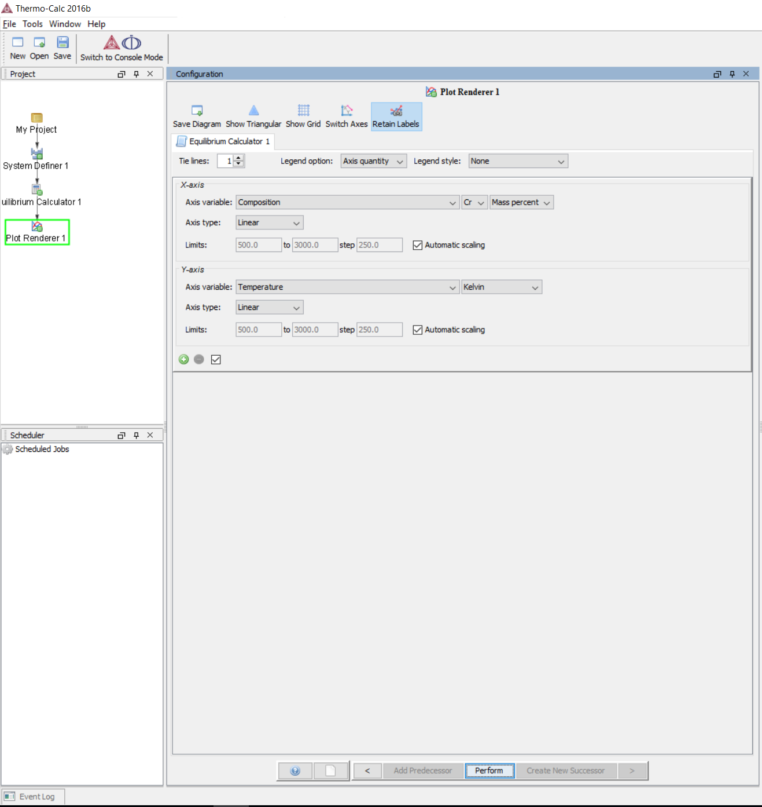

The Fe-Cr binary phase diagram will be calculated and plotted automatically.
TIP: Double click on the Results heading to maximize/minimize the plot.
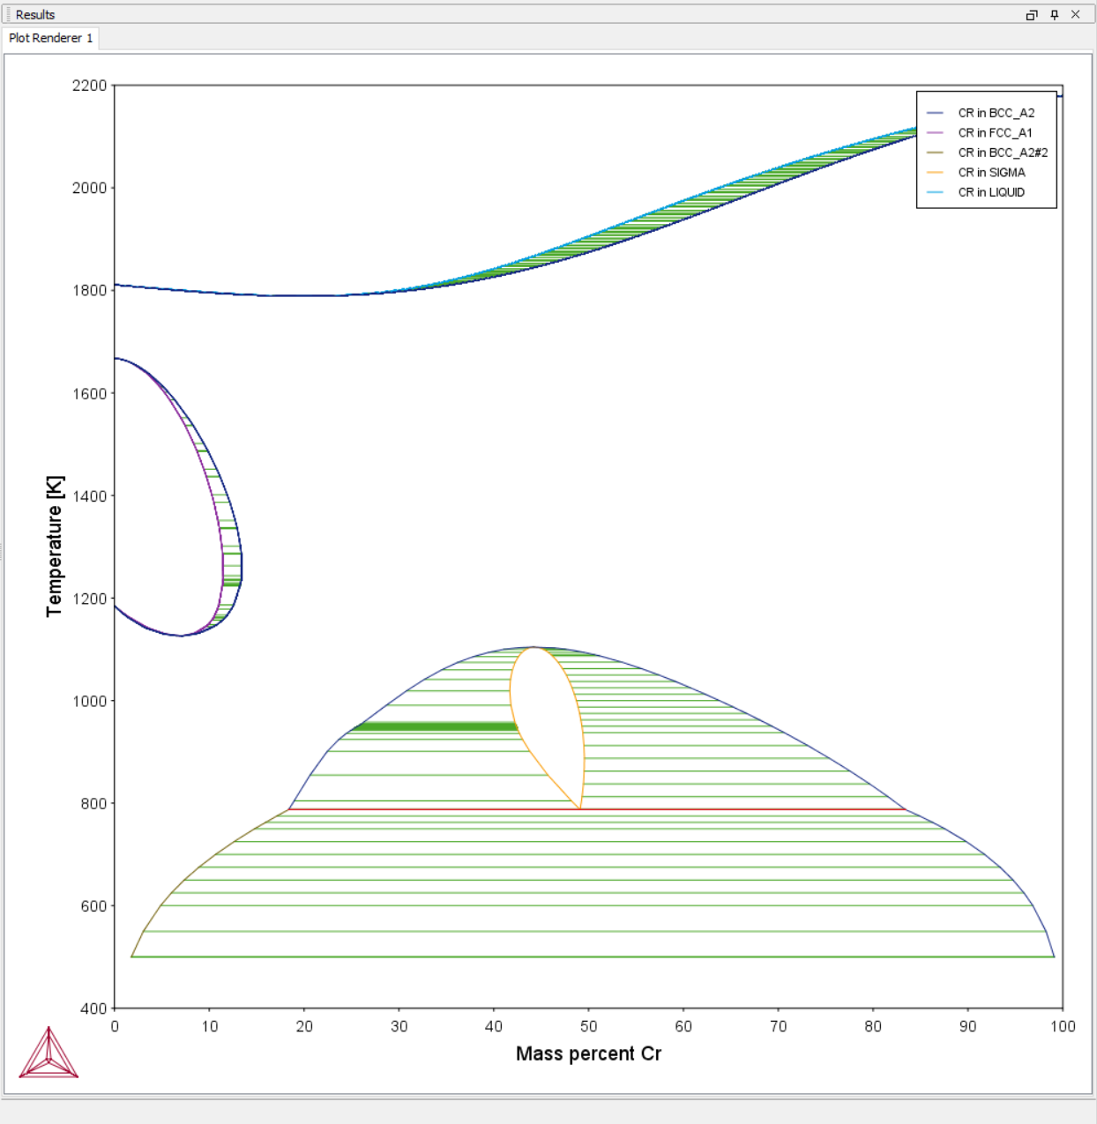

2. Plotting Free Energies for Fe-Cr system
2.1 From the initial window choose Binary Calculation Template

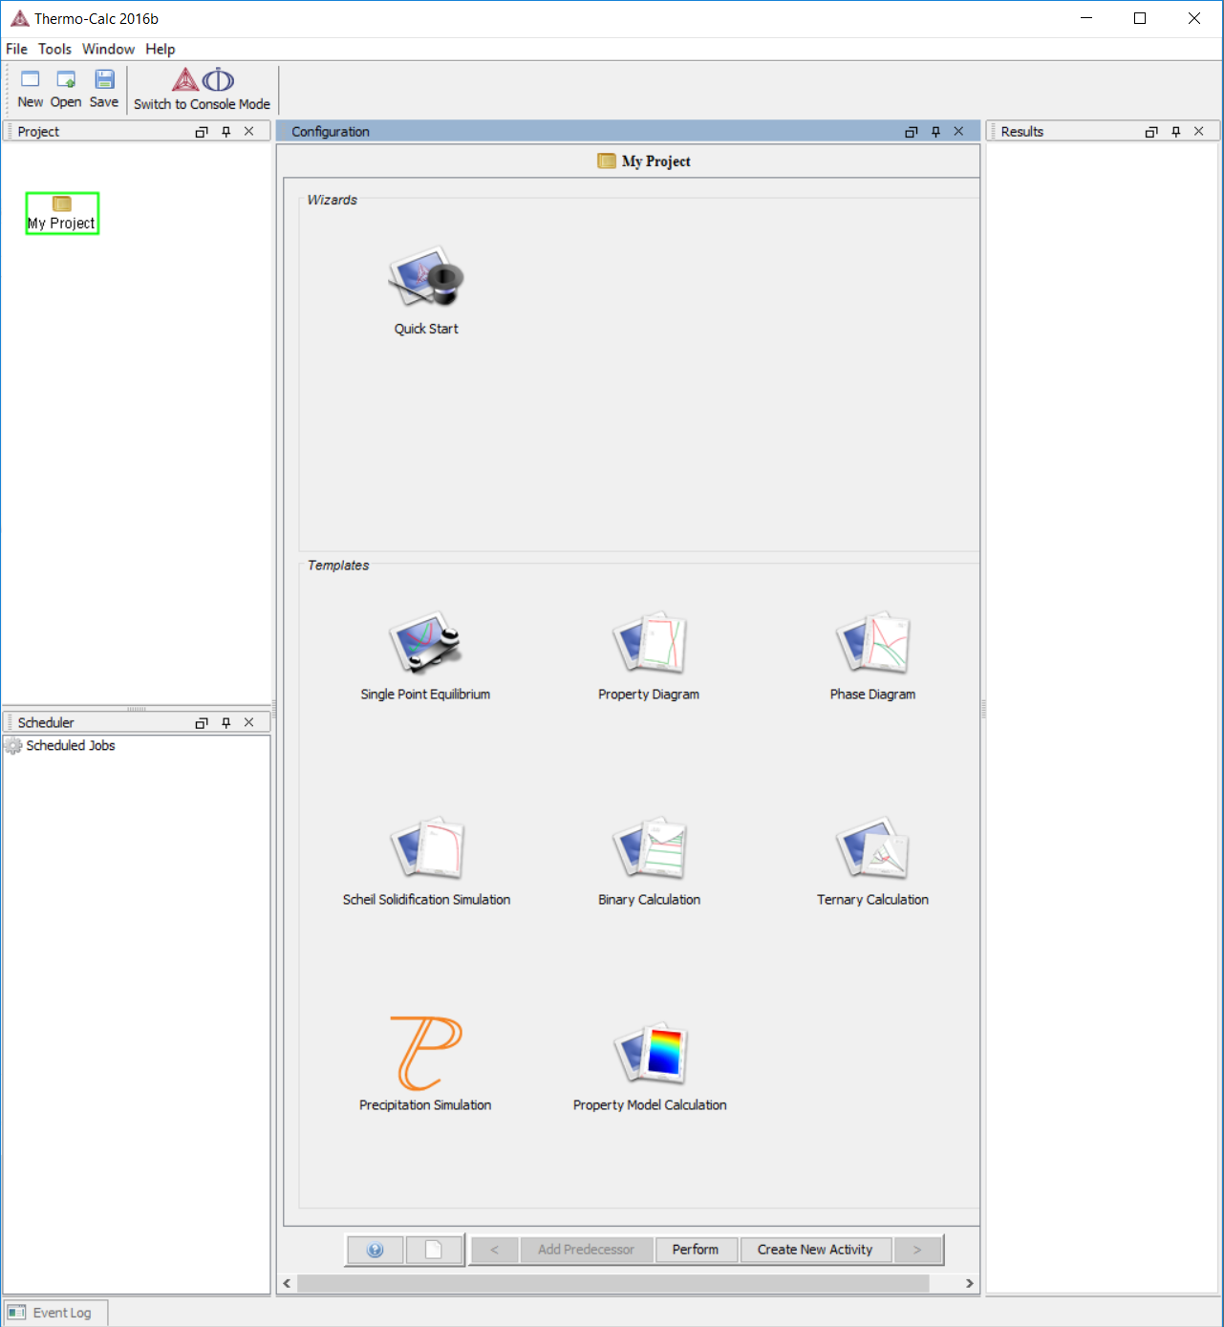

2.2 Select the elements Fe and Cr from the periodic table, change the Calculation Type to Gibbs energy curves, set the temperature to 673 K, and then click next ( > )
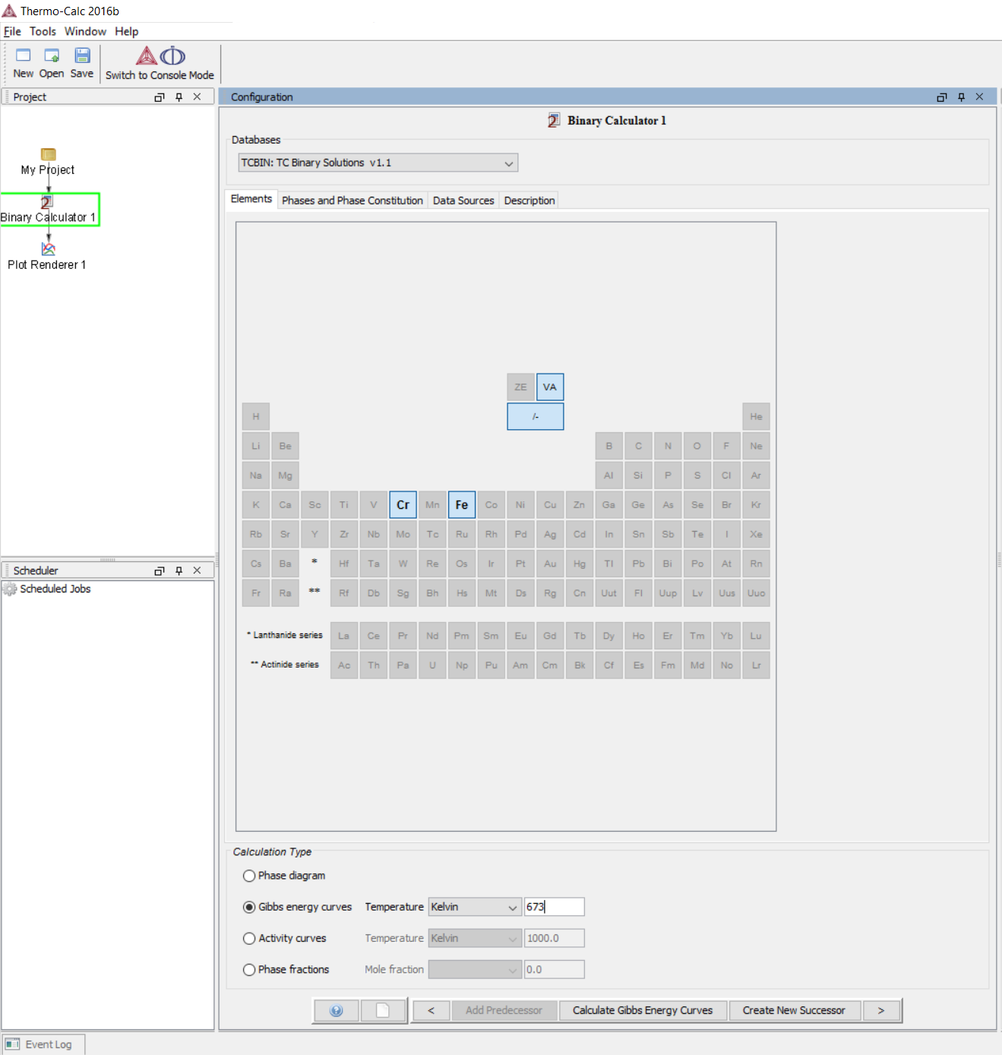

2.3 Again, you can set the axes as you wish, but for now, just make sure they are the same as this screen and the click Perform. 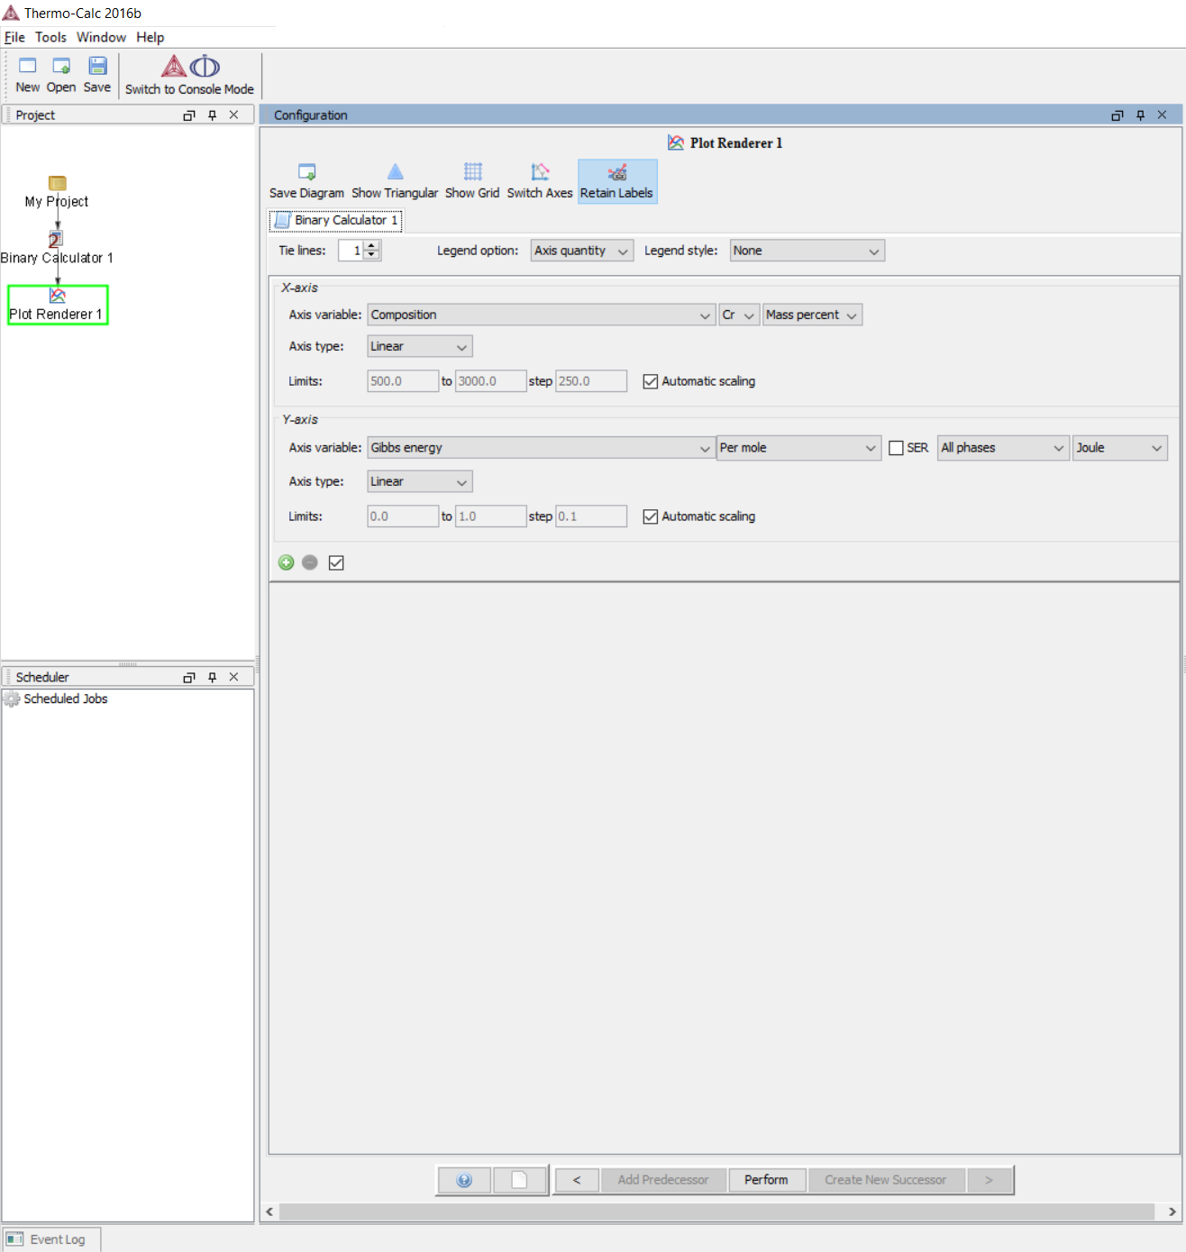

The Gibbs free energy curves for each phase will be plotted as a function of Chromium mass percent.
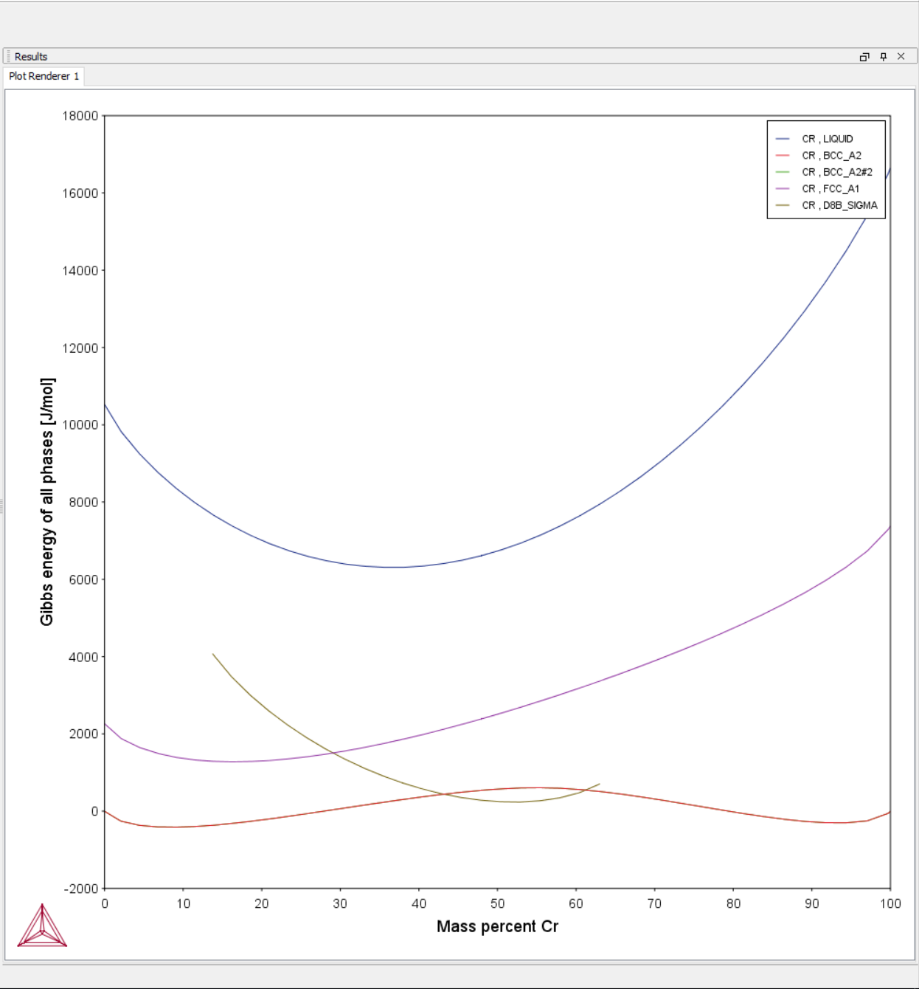

3. Plotting Phase Fraction and Compositions for the Fe-Cr System
3.1 From the initial window click Property Diagram.
3.2 Make sure the database in use is TCFE7 (or if it is not there, FEDEMO or another TCFE database) and choose Fe first and Cr then click next ( > ) 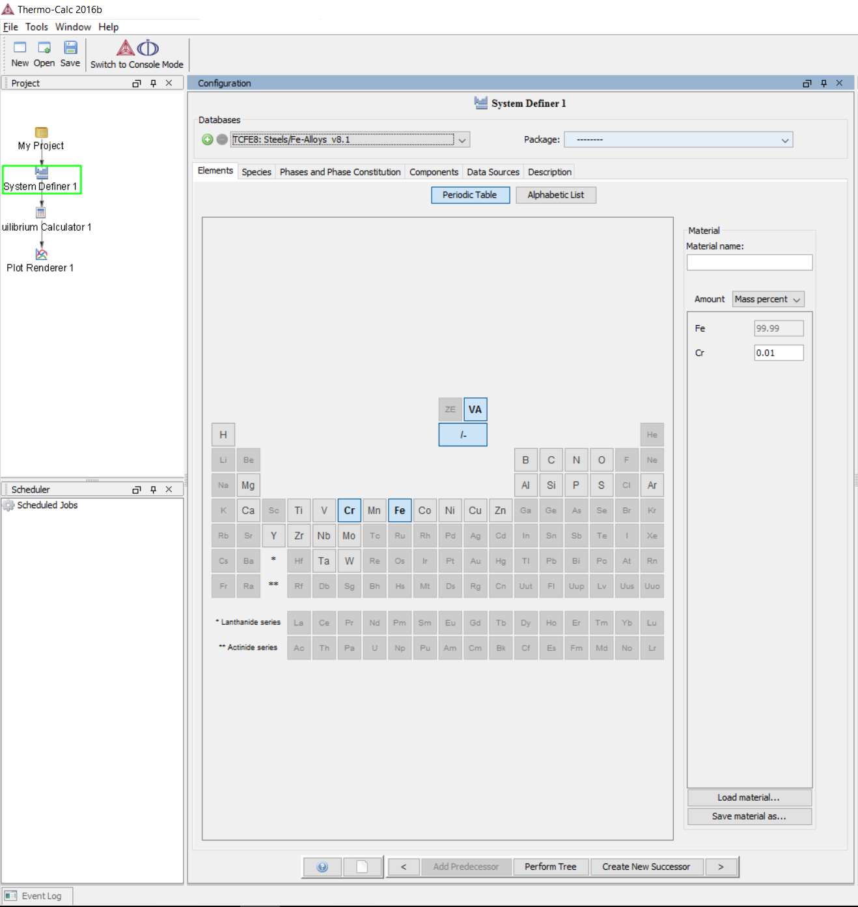

3.3 Set the temperature to 673 K and Cr composition to 0.1, the Fe composition will be adjusted automatically. Select Property Diagram and make sure the Axis Definition has Mass Percent Cr selected, the default values should be fine. Click next ( > )

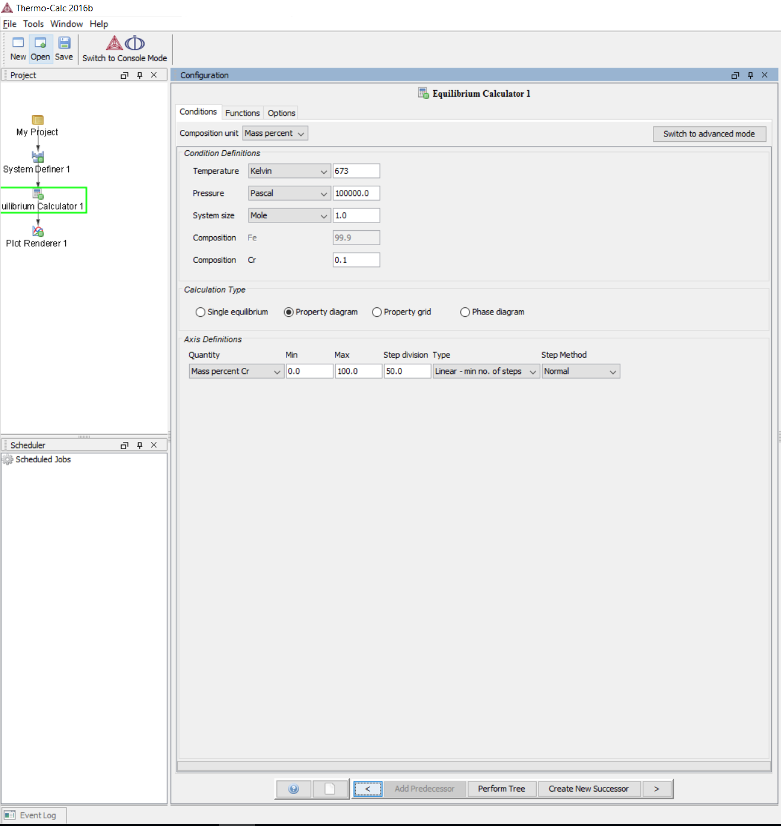

3.5 Set the X-Axis as Composition and then Mole Fraction of Cr and the Y-Axis as the Amount of phases for all the phases. Click Perform.
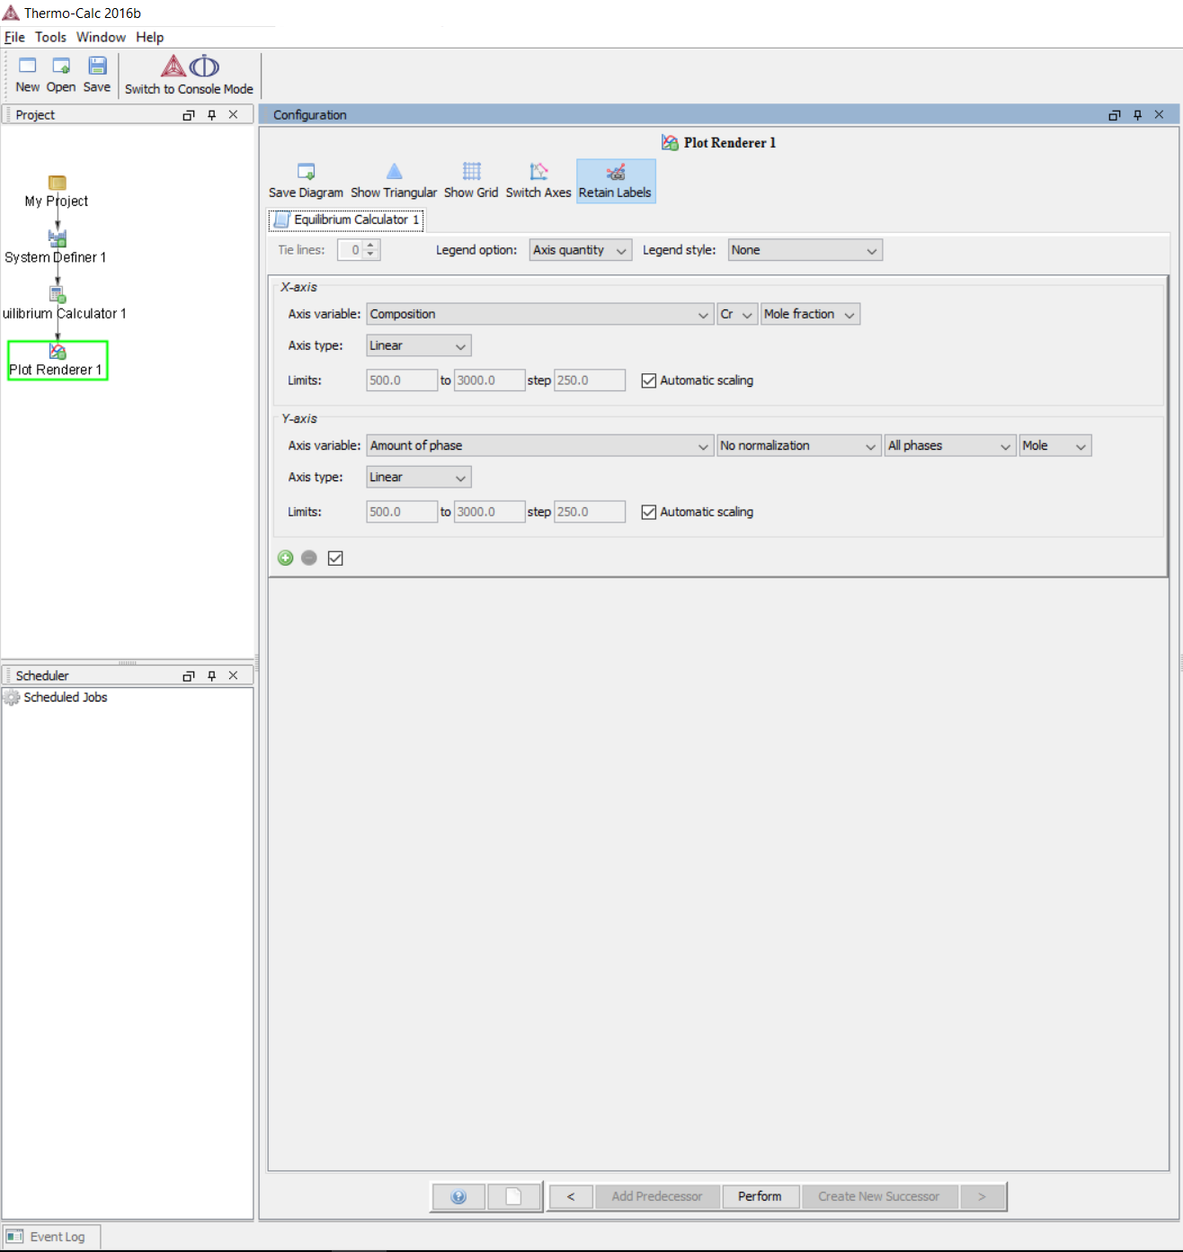

3.6 The phase fraction for the stable phases will be plotted as a function of x_{Cr}. To label the plots for each phase, do so by choosing Add Label from the right-click choices.
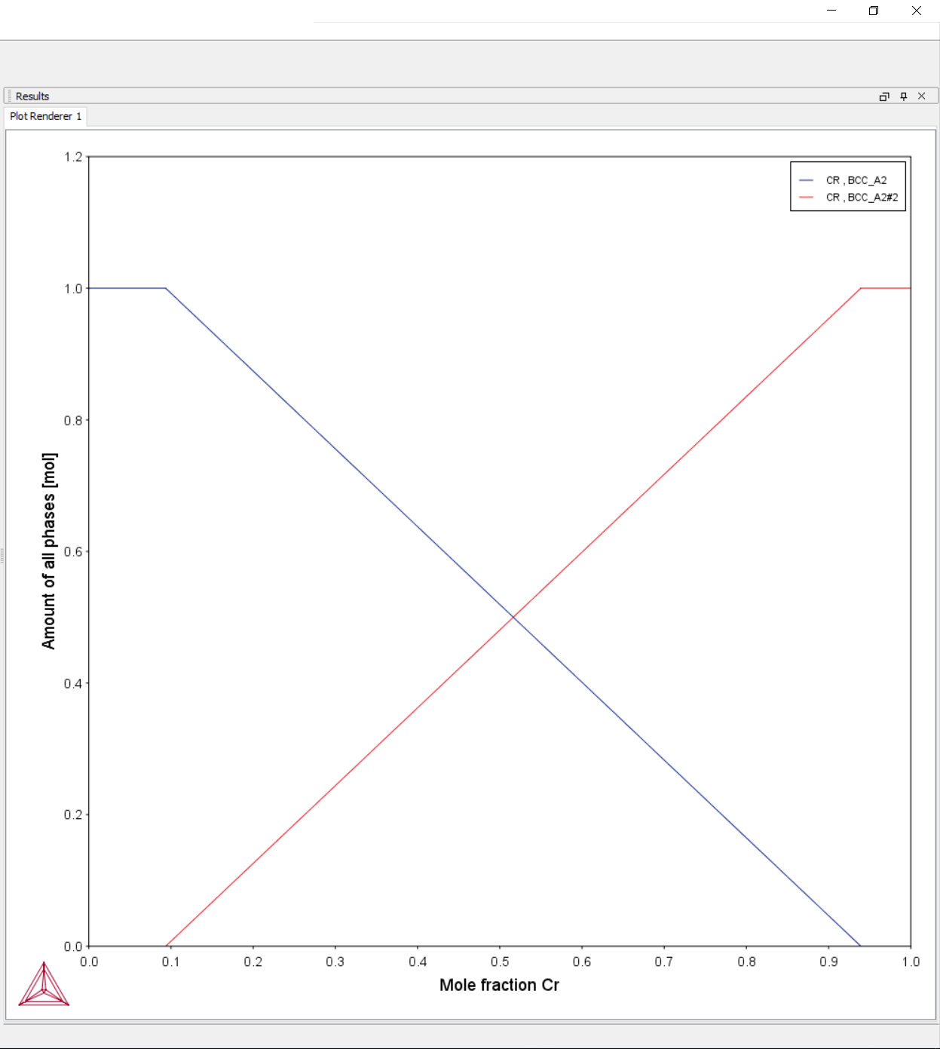

Now we are going to do the exact same thing, but through a different method. If you are not interested in the alternative method, skip to 3.12

3.7 From the initial window choose Quick Start

3.8 Choose Property Diagram, then click Next

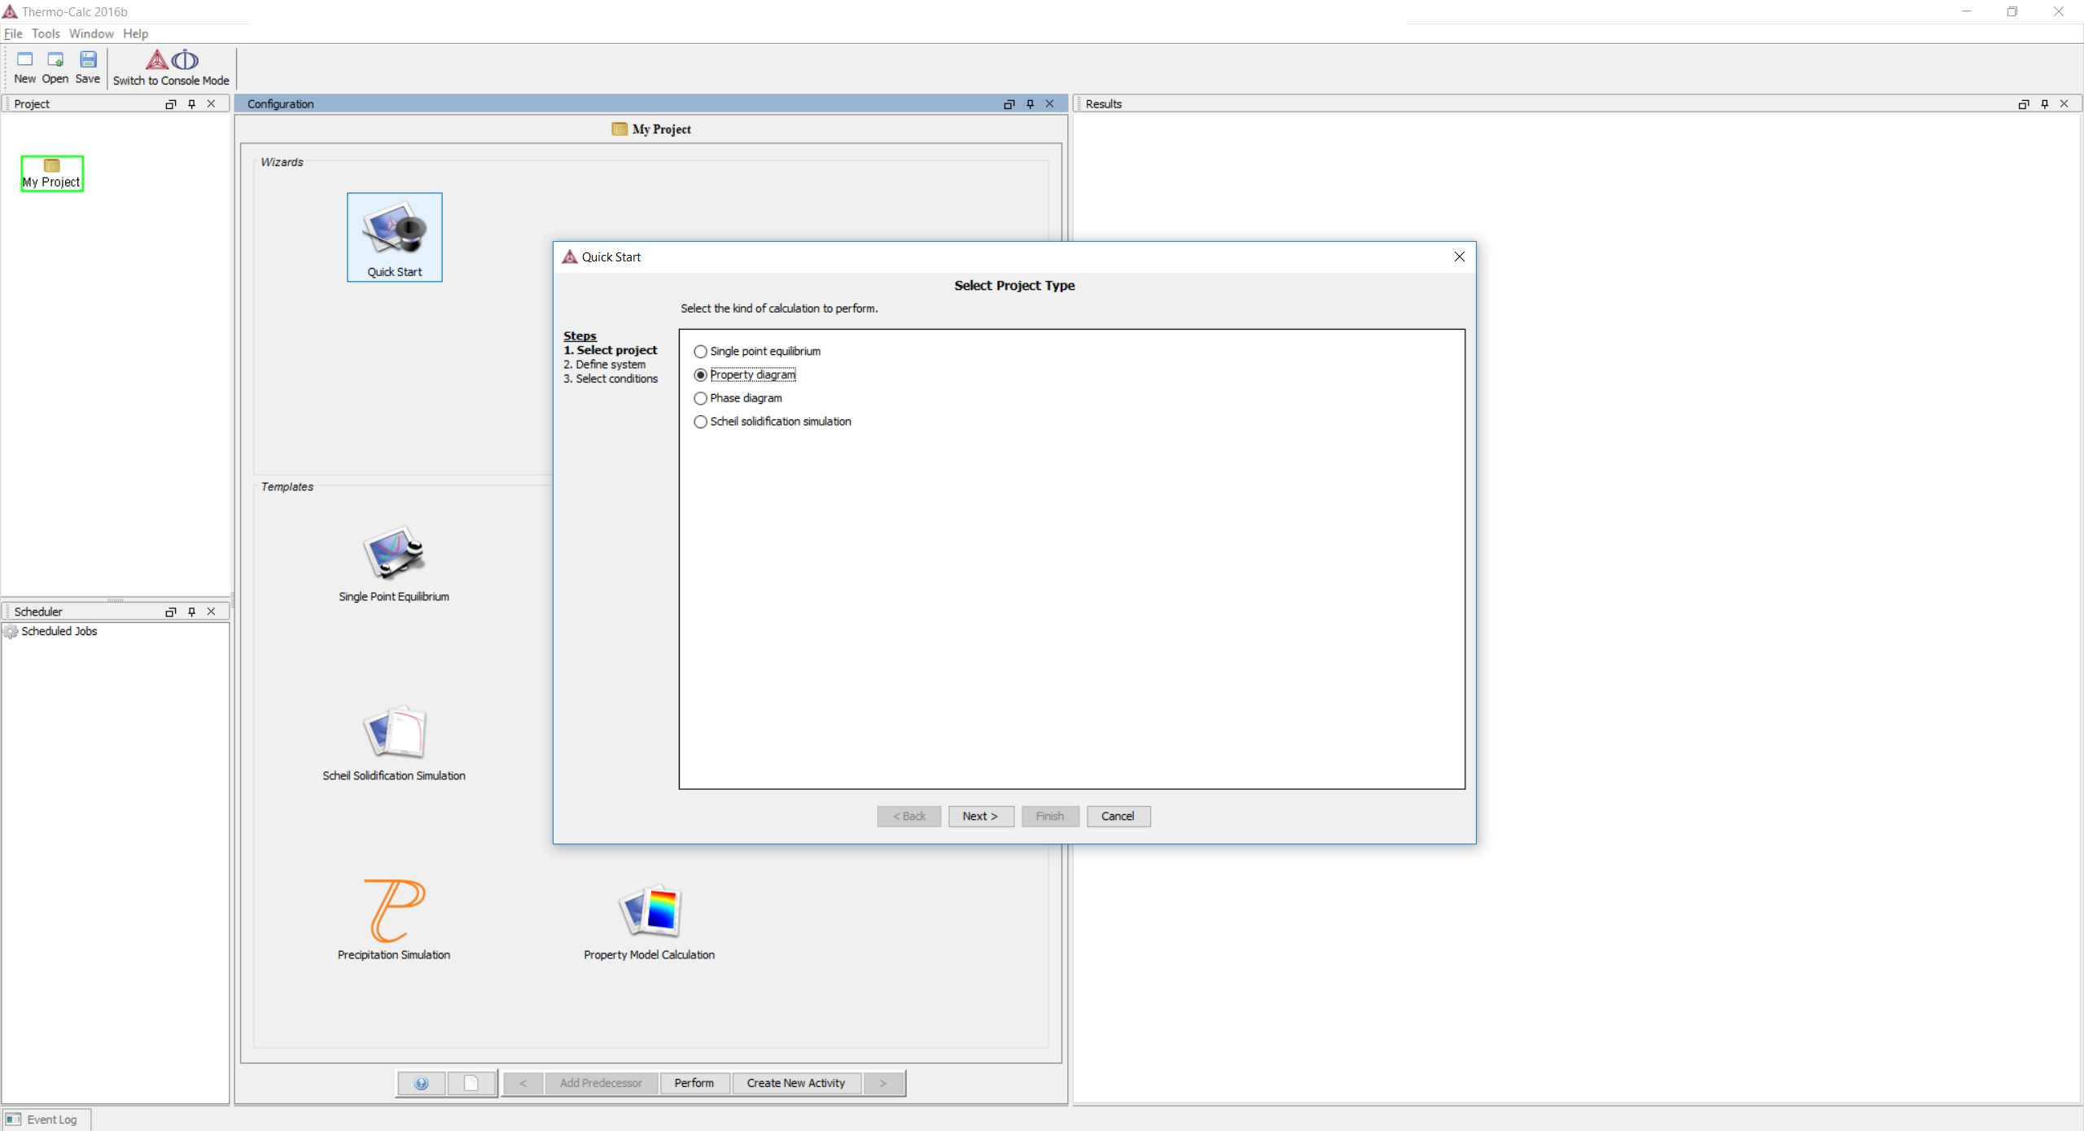

3.9 Same as before, but through a different screen, make sure the Database is TCFE7 (or FEDEMO) and pick Fe first and then Cr. Click Next. 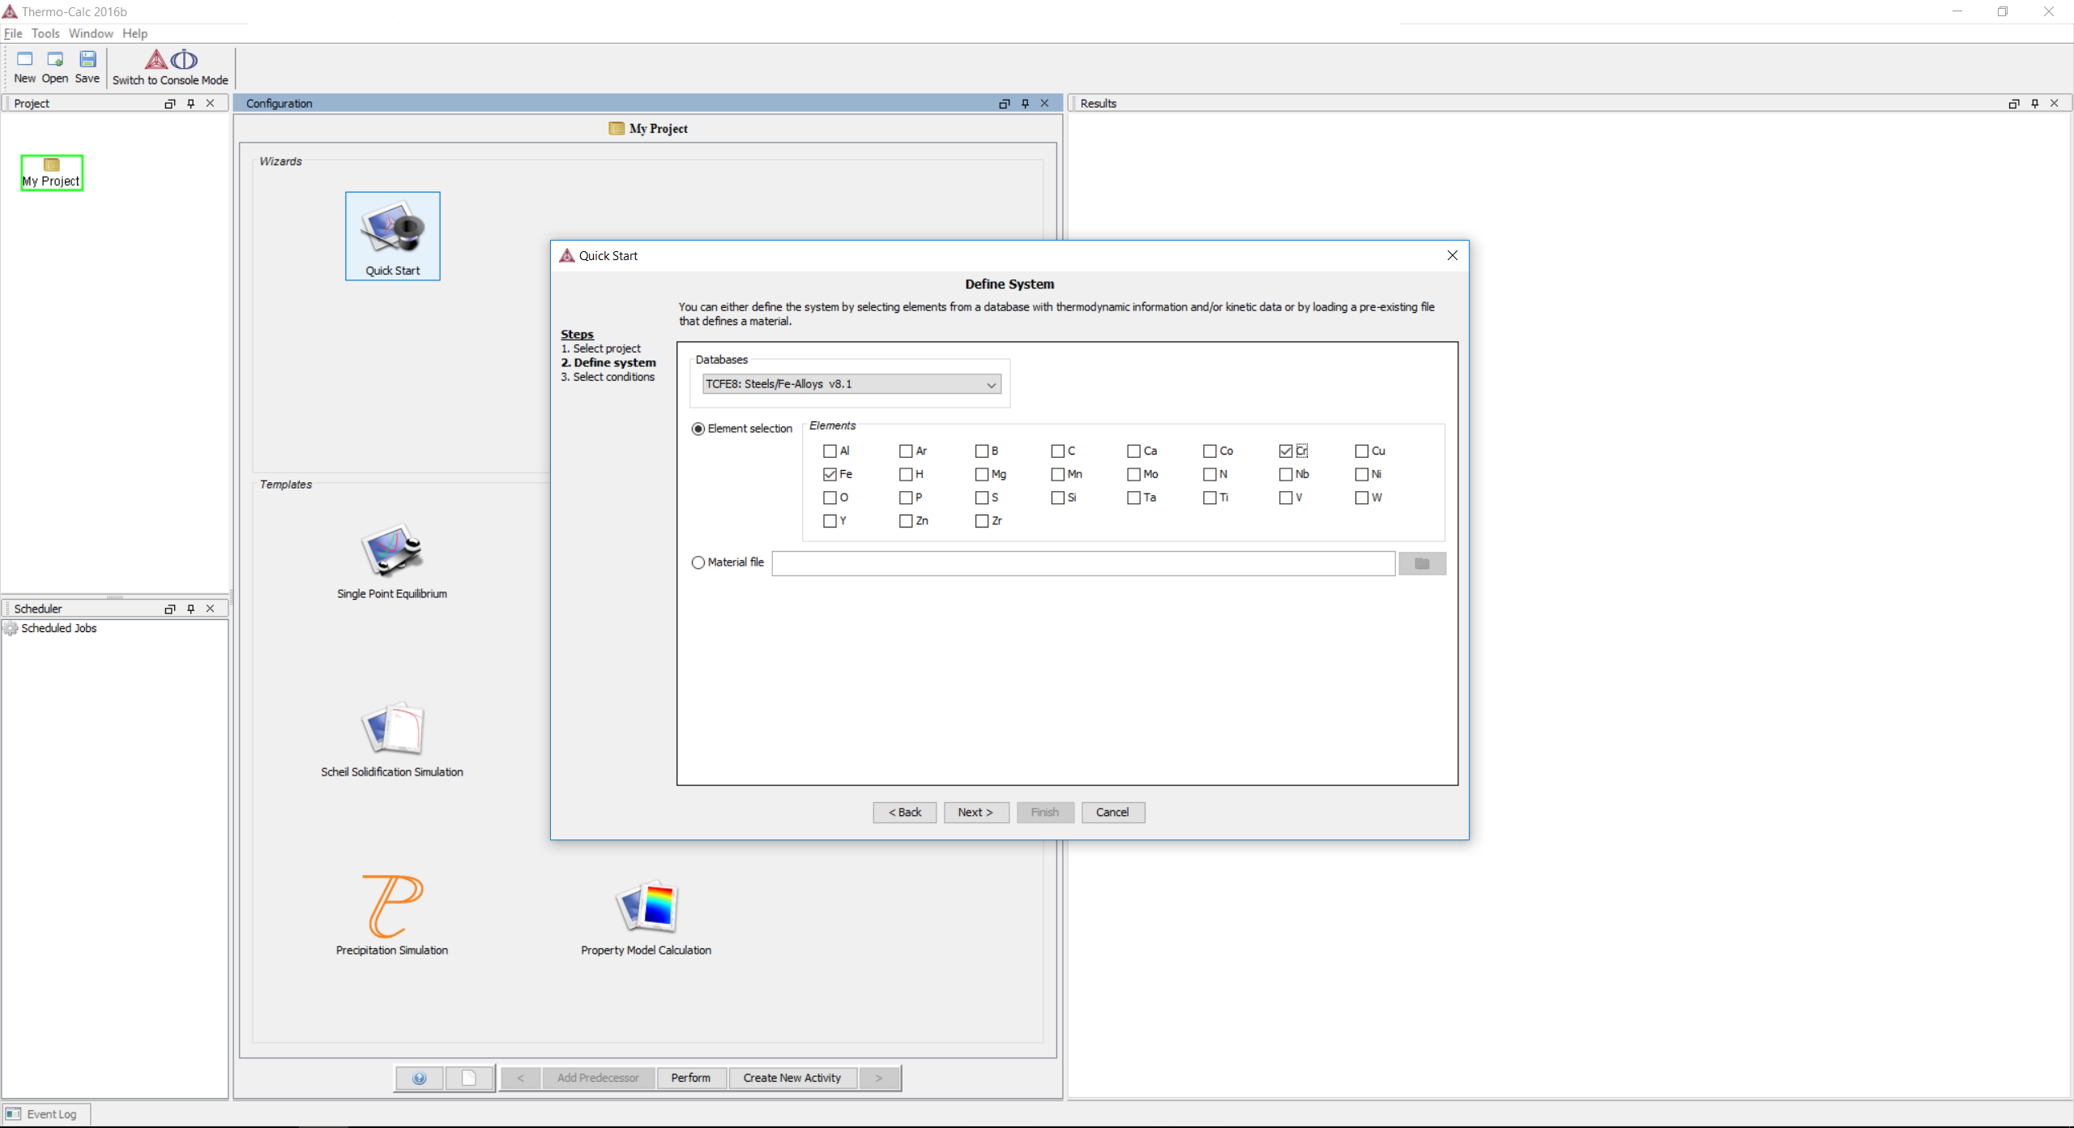

3.10 Set the temperature to 673 K and Cr composition to 0.1. Set the active Axis Definition to Mass percent Cr. Click Finish.
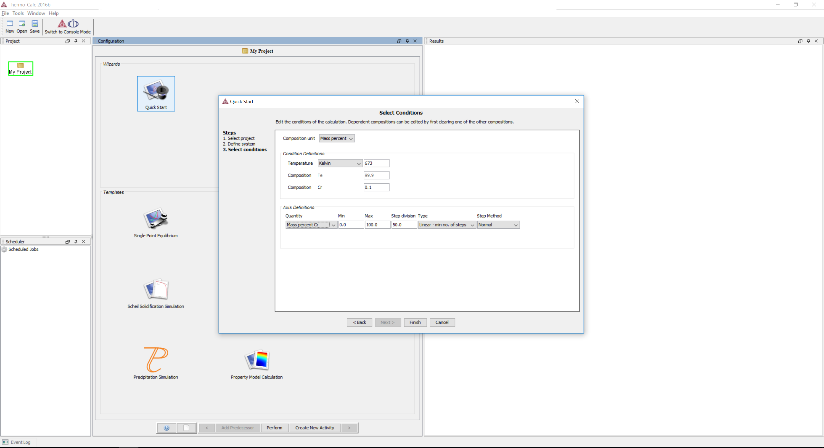

3.11 You will automatically get the same plot as before.
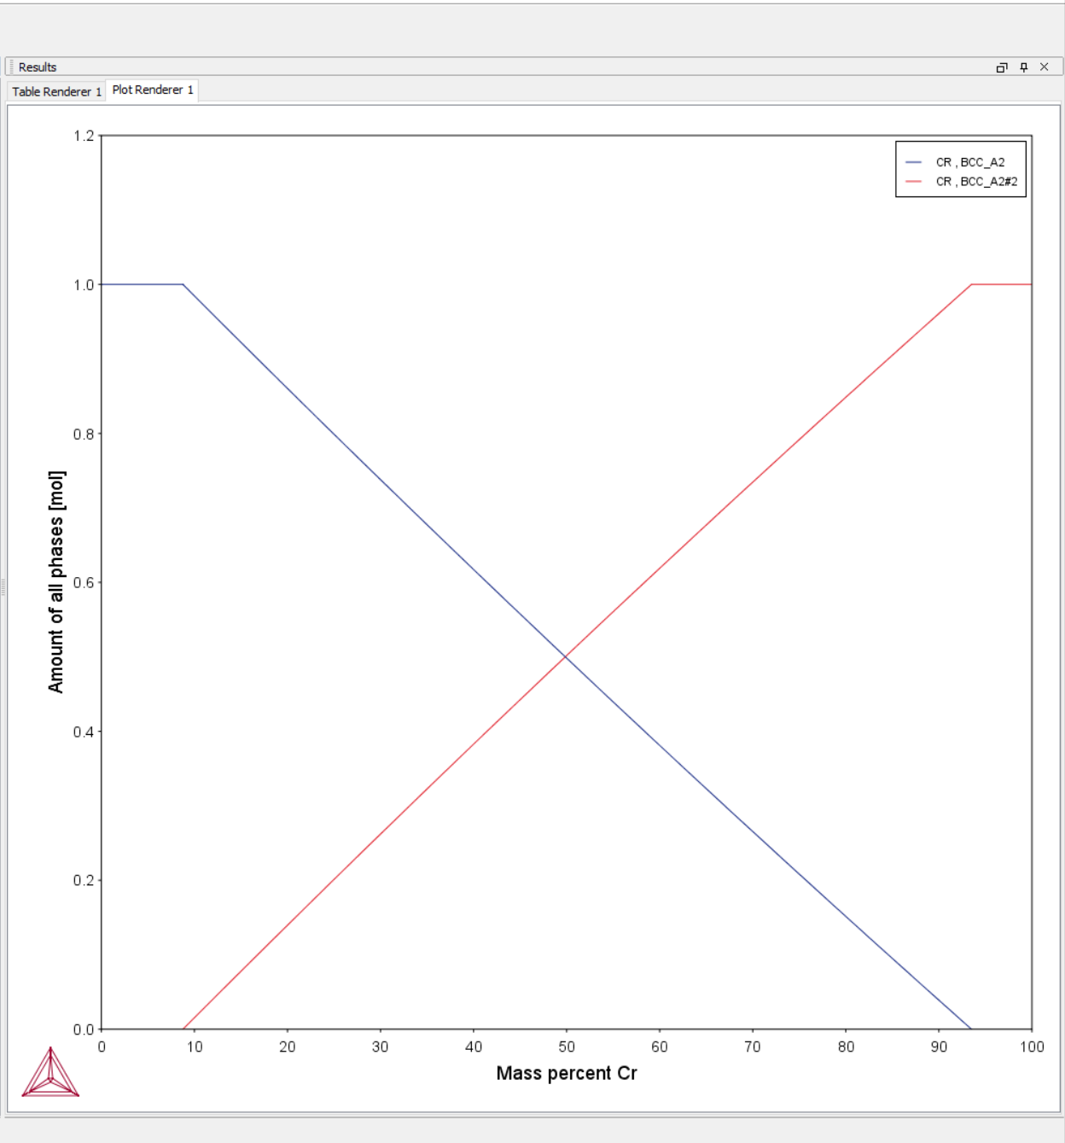
While using Quick Start is often faster, there are less settings you can tinker around with, but you can always click back ( < ) after the plot has been generated to change the settings as necessary.

3.12 From either 3.6 or 3.11, to change to plot to see the Cr content of each phase, change the Y-Axis settings to Composition of a phase for All phases with Cr.
If in the Legend option you change Axis quantity to Stable phases, the line will be marked with the stable phases for that composition range, but for most cases we want to just leave the setting as Axis quantity. 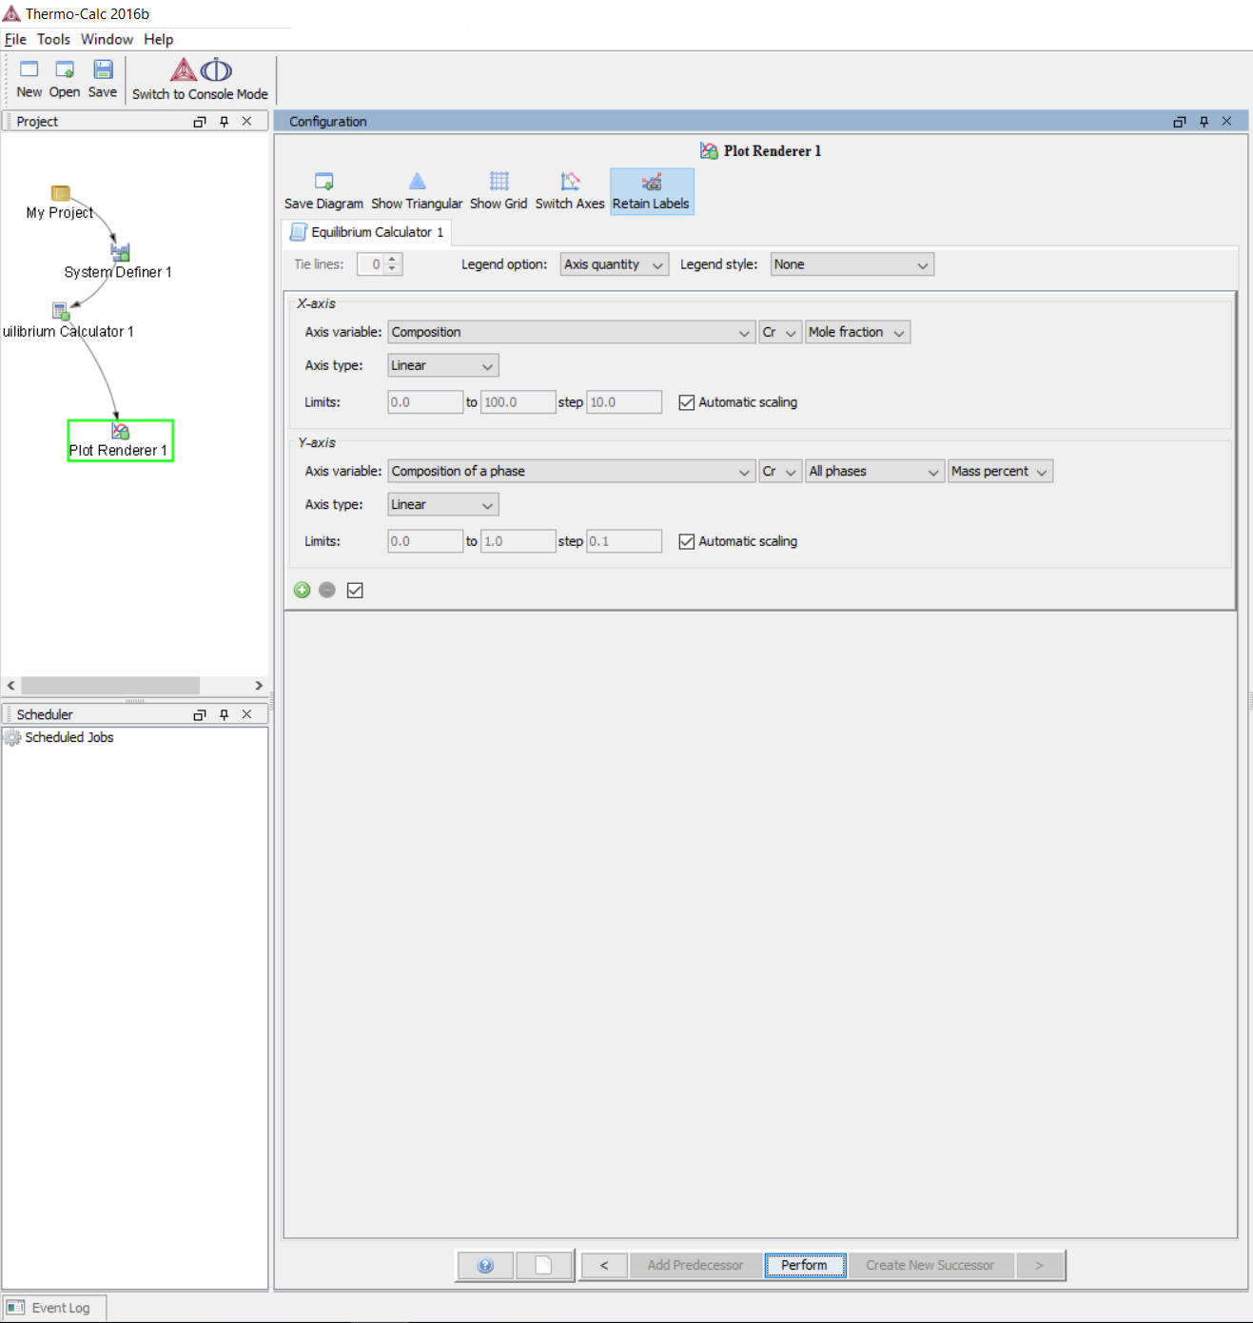

3.13 The plot should change automatically, if not click Perform again. You can move the legend with your mouse to see the entirety of the plot.
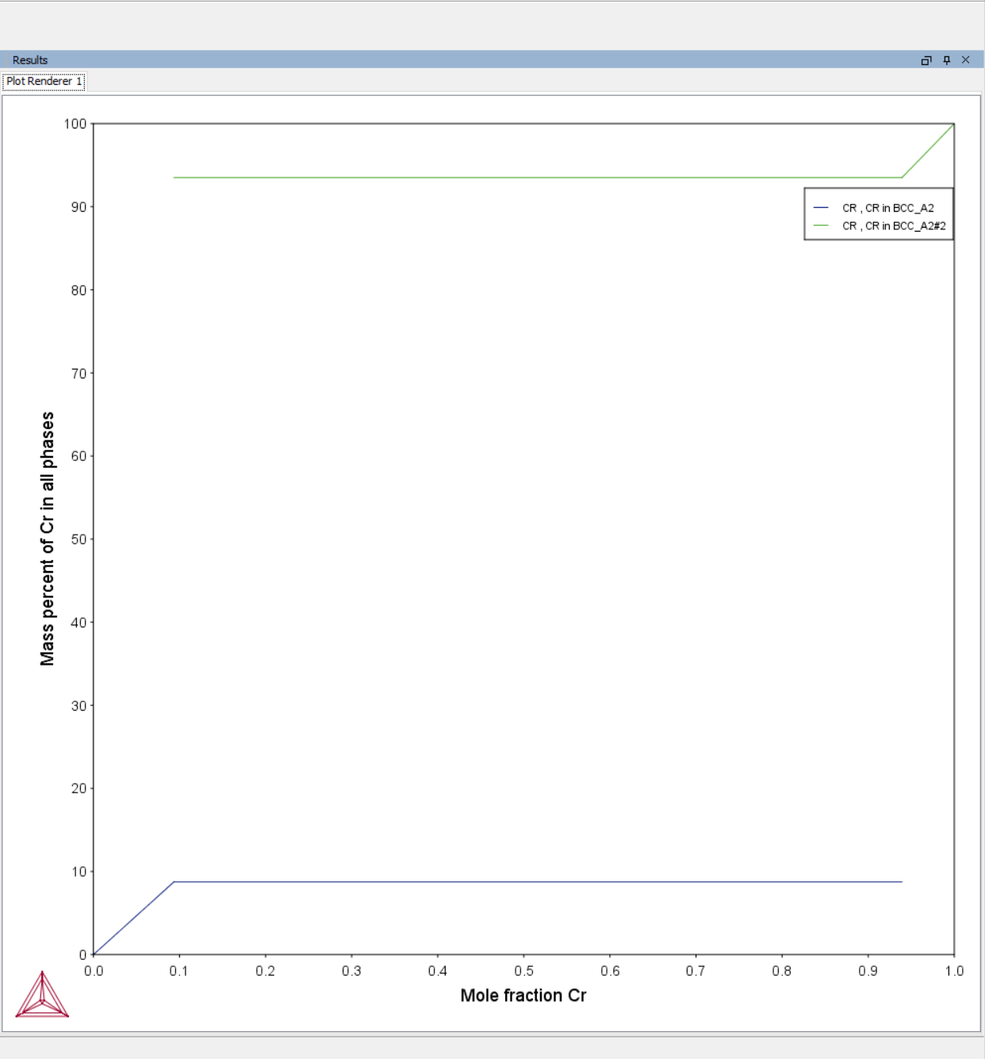

4. Calculation of Isopleth in Fe-8Cr-1C System

4.1 From the initial window, choose Phase Diagram.

4.2 Select FEDEMO from the Database list and then click alloy elements Fe first, then Cr and C in the periodic table and then click next ( > ). 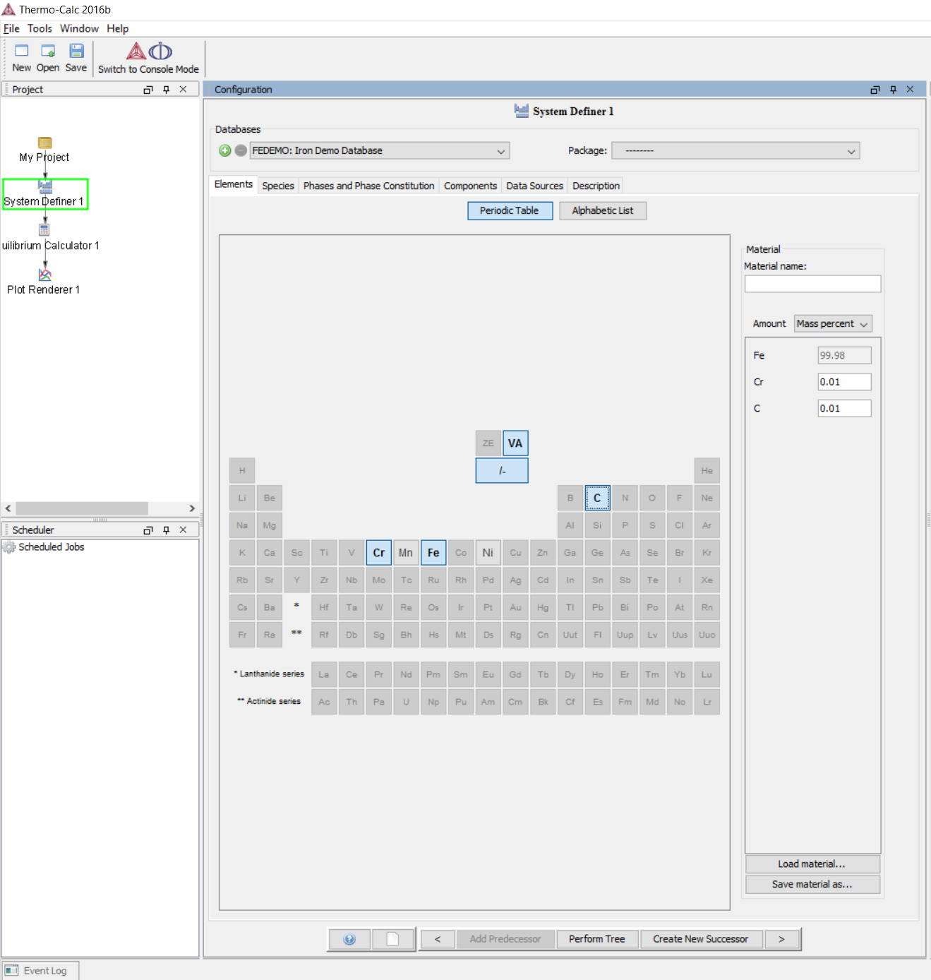

4.3 Set the Cr concentration at 8% and C at 1%. Make sure both Axis Definitions are active, set the minimum temperature to 773 K and the maximum to 2273 K. Click next ( > - Plot Rendering option )
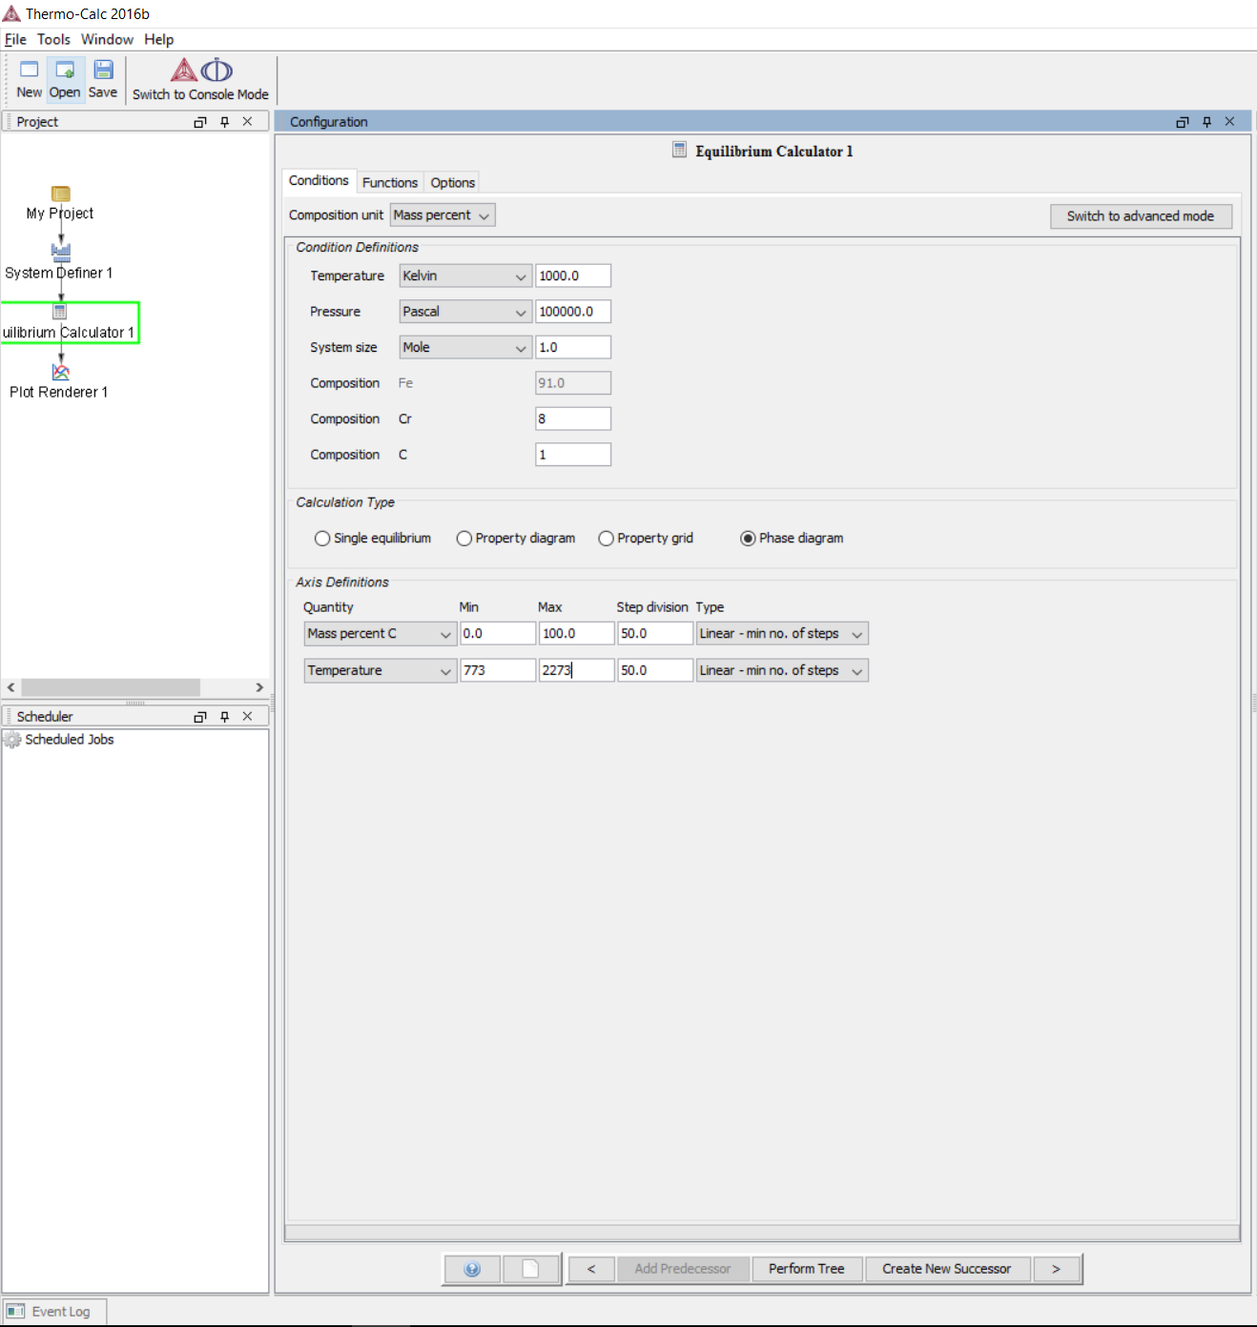

4.5 Set the X-Axis as composition C in Mass percent and Y-Axis as temperature in Kelvin. Set the Legend option to Axis quantity. Then click Perform.
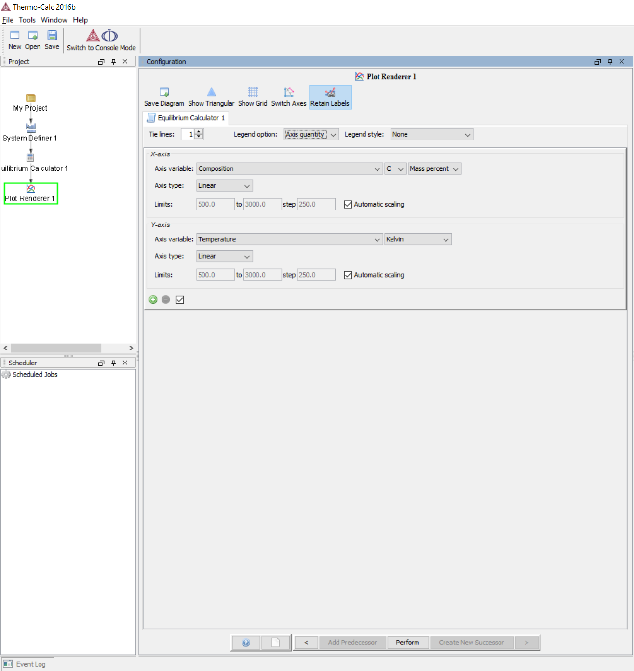
4.6 We now have the Isopleth.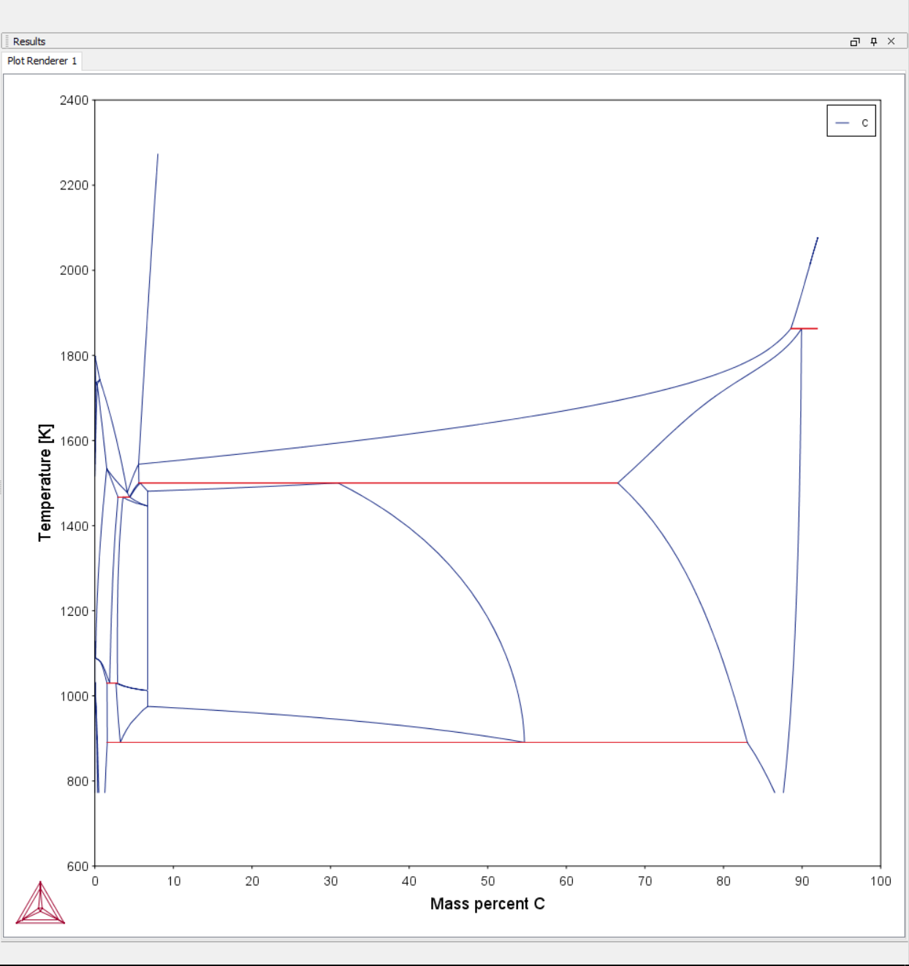

4.7 To zoom in to the interesting parts you can use your mouse to drag over the region of interest and zoom in. An upward swipe motion with the mouse zooms back out. You can also, in the previous window, deactivate automatic scaling and set the limits for X-Axis to be between 0 and 3, and Y-Axis to be between 800 and 2000. In addition, set the Legend option to Stable phases, so we can see where the stable phases are. 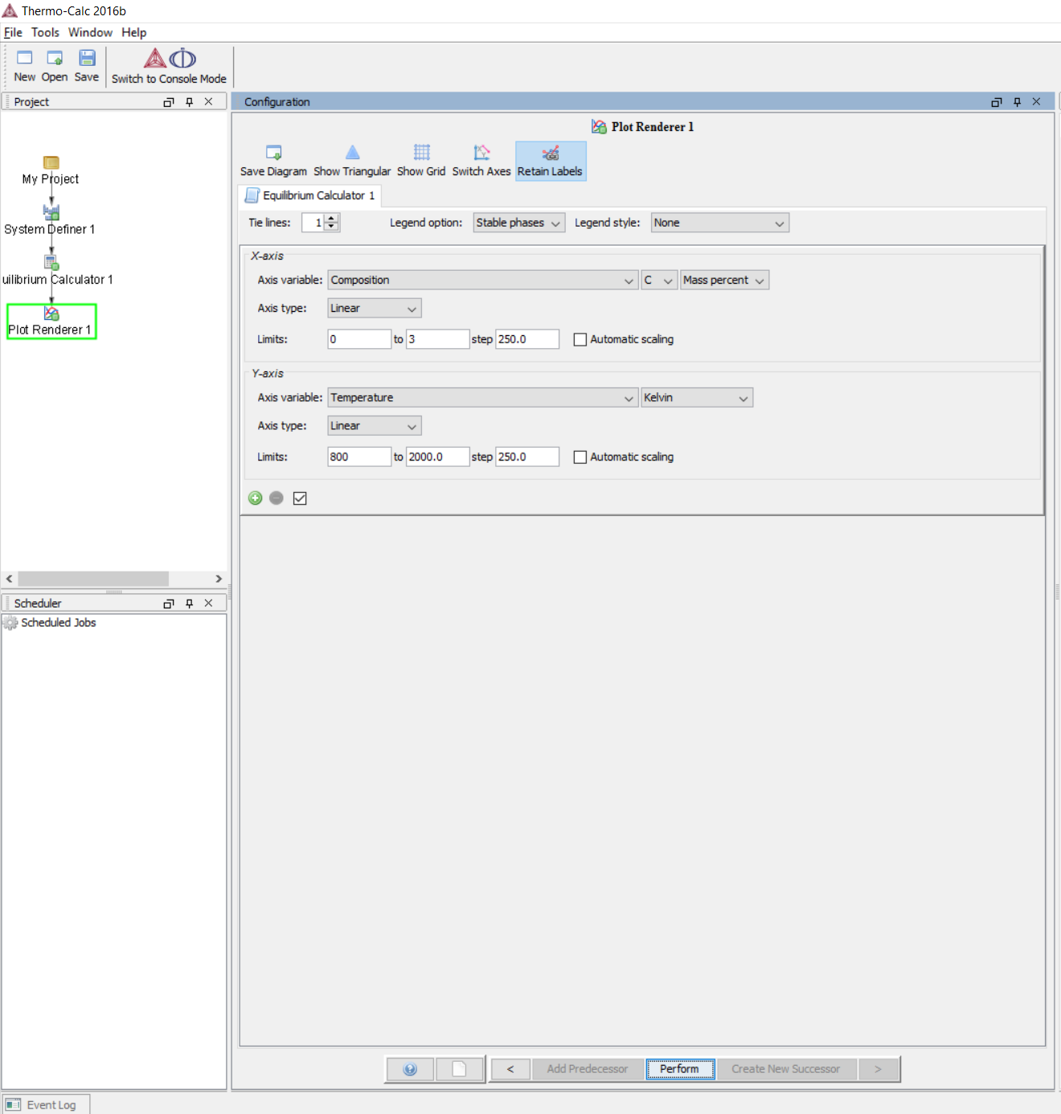

4.8 The plot should re-adjust automatically, otherwise click Perform.

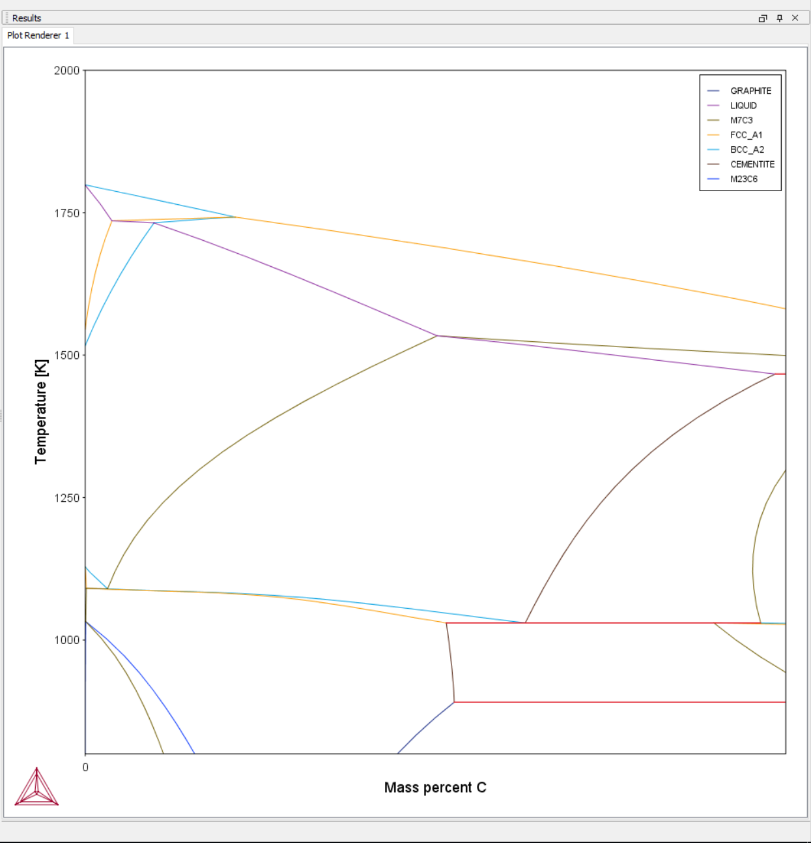

4.9 Finally, we can label the phase regions by right-clicking and choosing Add Label on the area we want to add label to. You can shift the position of the label by dragging it. The label will be "anchored" to the point where you right clicked, unless you disable said setting. (There was issues with this feature on the OS X version)

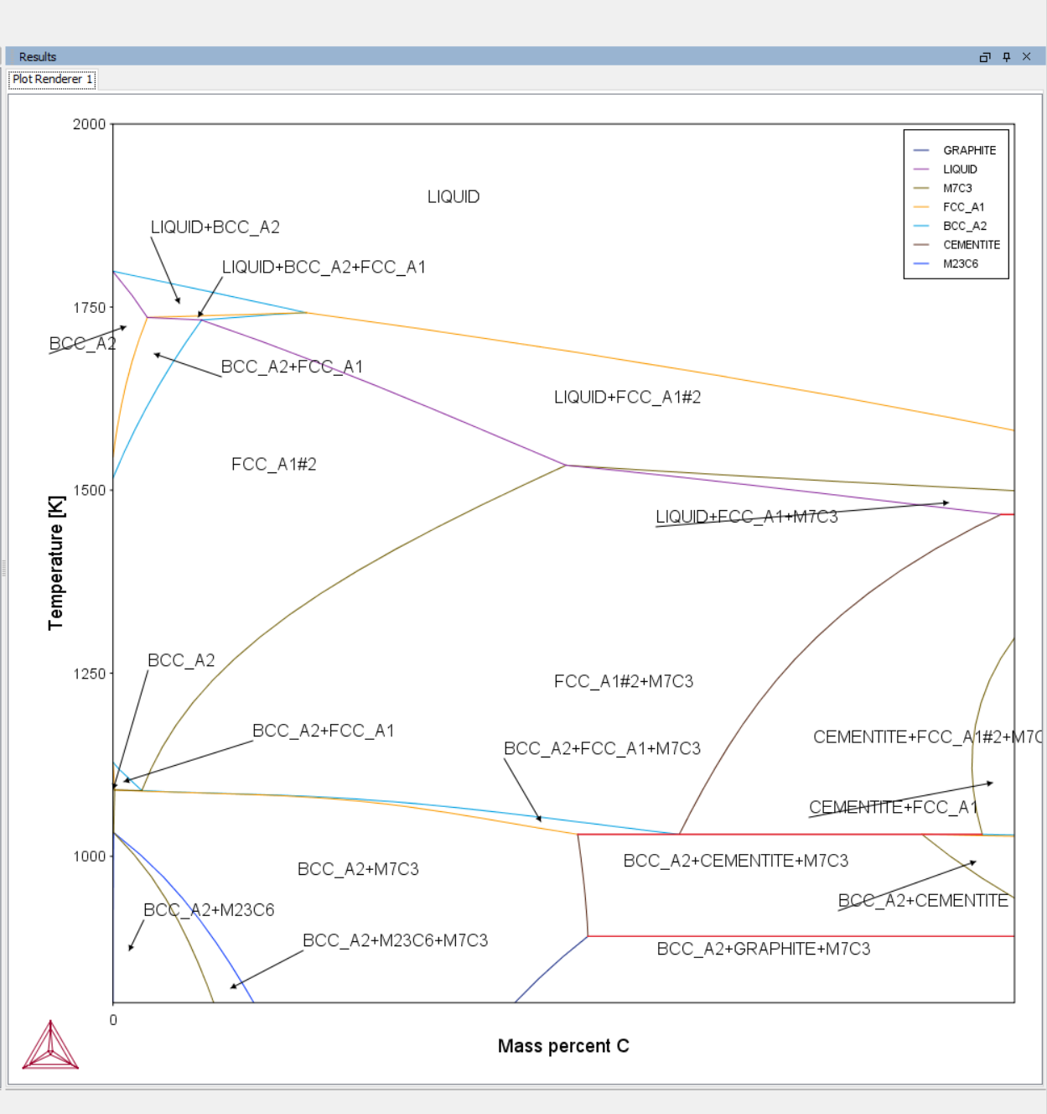

Other things:
You can right-click on objects in the Project window to add/branch/remove components in your project manually. You can do everything in this walkthrough in a single project; use the Project window to navigate between calculations and keep everything organized.

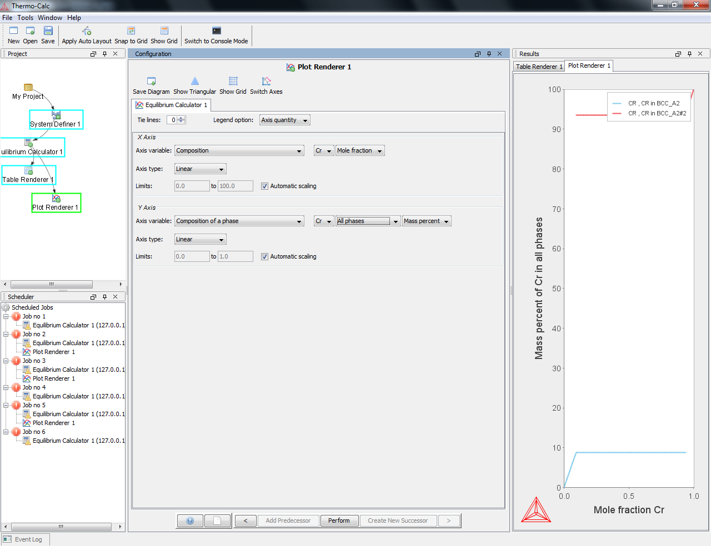

To make changes to a plot without overwriting your current plot, you can copy the Plot Renderer. To do this, right-click on the Plot Renderer in the Project window on the left and select clone in the drop-down menu.

If you accidentally close the Results window or the Configuration window, you can reopen it by clicking on Window in the top left corner and selecting the window you want to open.

